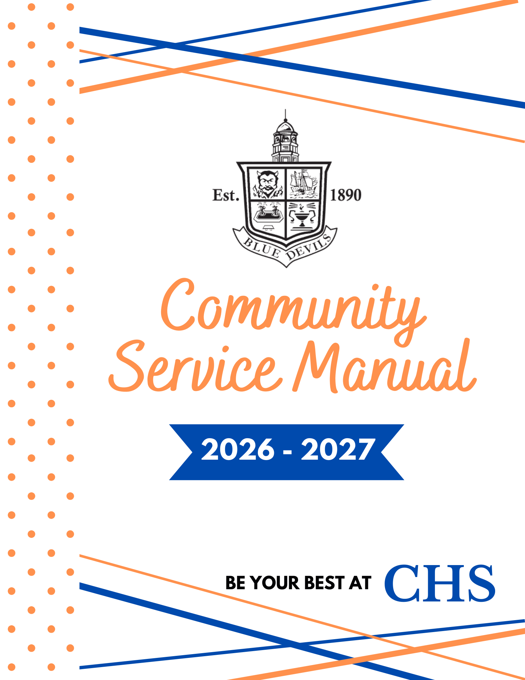
2026-2027 Summer Community Service Guidelines

Please read carefully. Many questions we get through email are
answered in this document.

Being your best at Columbus High School takes commitment to studying, being involved and upholding a high standard of integrity. Every aspect of our program is designed to provide opportunities for students to develop academically, emotionally, socially and ethically. When accepting the offer to be a student at CHS and signing the Declaration of Commitment, you committed to ‘being involved in the total magnet program by participating in community service’.

In preparation for completing your community service requirement for the 2026-2027 school year, here is what you need to know:
  - Each 9th, 10th and 11th grade student must complete 20 hours of community service per year. Seniors (12th graders) obtain their community service hours via AP Capstone or their Senior Project.
  - All 20 hours must be completed with the original agency selected by the student during community service registration. Students cannot obtain hours through multiple agencies or with any agency outside of our approved list.
    - Except in the case of extreme extenuating circumstances, students are not permitted to change agencies during the school year.
- In order to maintain integrity of the program, students may not serve at any organization that employs their parents. More specifically, a relative cannot serve as a volunteer supervisor to a family member.
- Volunteer hours can be completed anytime between September 11, 2026-April 30, 2027.
  - Therefore, extracurricular activities, going out-of-town, or other scheduling conflicts will not be accepted as reasons for not meeting the community service completion deadline.
  - We are here to help meet the needs of the agencies. It is not the responsibility of your agency to work around your schedule or create service opportunities because you waited until the last minute to start your hours. Many agencies have scheduled events at which they utilize volunteers. Please work your own schedule around these events.
  - Successful completion of community service hours is a Magnet requirement, per the Declaration of Commitment you and your parents signed when you accepted a spot in this program. Failure to complete your hours will result in being placed on a Magnet Probation Contract. This is the first step of the revocation process.
- Conduct Expectations
- Commitment-Think of each service activity AS A JOB. Establish your commitment early by planning the days and hours you are going to work well in advance, if at all possible.
- Always be on time. If you are unable to work on your scheduled day due to an emergency, notify the supervisor for your agency in a timely manner.
- Dress appropriately for your job assignment.
- Conduct yourself in a manner that reflects positively on your status as a Columbus High School student and you as a person. Students will be held to the MCSD and CHS codes of conduct.
- Note to Parents/Guardians
Volunteers play an important role in the success of our partner agencies. The volunteer coordinator for each agency knows how many volunteers are needed each day or for each event. It can negatively impact the agency’s effectiveness when students do not fulfill their commitments. We value our partnership with each of our agencies and strive to maintain a positive relationship with them. Except in the case of an emergency, please help us maintain the relationship by insisting that your student meet his or her obligation.

At the end of the day, our hope is that community service will allow our students the opportunity to take their knowledge outside of the classroom to help meet the needs of other people. While community service does help build a resume necessary for college applications, scholarships, and future employment, a resume booster is not our goal. More than anything, we want our students to leave CHS with a greater awareness of the world around them, a stronger sense of empathy, and a desire to serve others that lasts a lifetime.

REGISTERING FOR AN AGENCY

Students will select a volunteer agency through our online registration portal. A list of the available agencies is listed below. Make note of agencies that pique your interest. Detailed information (general description, possible tasks, days/times, number of positions available, etc.) is provided in the portal for each organization.

NOTE: The registration process works best using the student’s Chromebook. Phones and non-MCSD devices may be difficult to navigate.
- Visit this link to start the registration process: http://apps.muscogee.k12.ga.us/SignMeUp.
- If prompted, enter your MCSD credentials: GTID number (not email address) and password.
- Click the green GO TO EVENT LIST button located in the bottom middle of the page.
- You will be taken to the Available Events page.
  - Thoroughly read the description/details provided for each agency. Some agencies have age or other requirements, so read all of the information carefully before making your selection.
  - Talk with your parent(s)/guardian about your selections. Since they may have to provide transportation for you, it is important to select something which also works with their schedule.
- Once you select the event (agency) where you want to volunteer, click Sign Me Up!
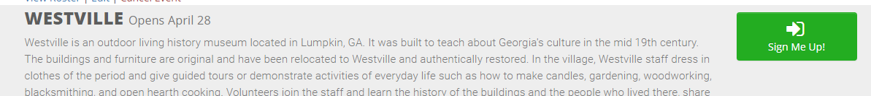

- At the bottom of the page, select the green REGISTER button. The Register button will only be available (green) under FALL unless it is a SUMMER ONLY opportunity.

Note: The Register button will not be available (red) if the slots have already been filled.
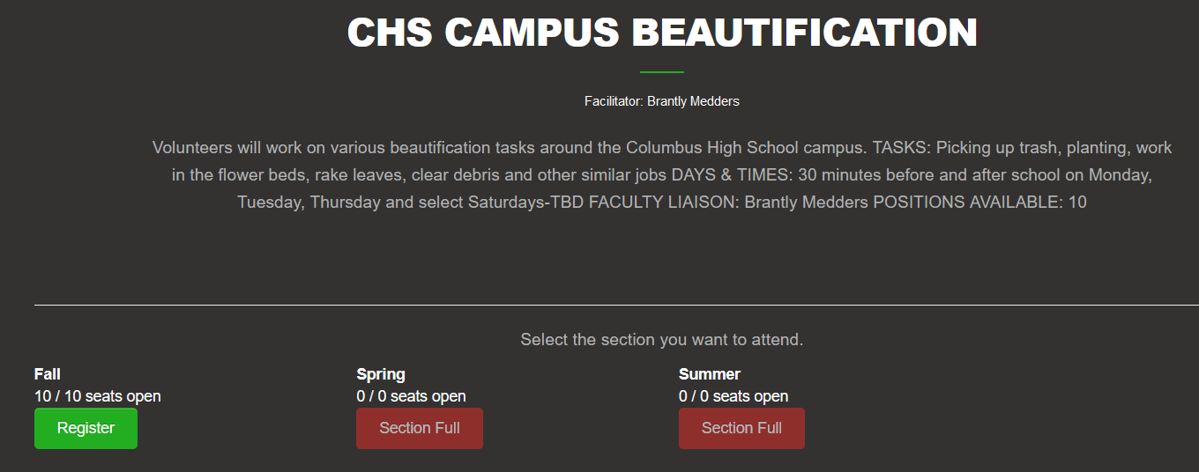

- Once the registration is completed, a confirmation box will appear with the message,
‘You have successfully registered for this event!’
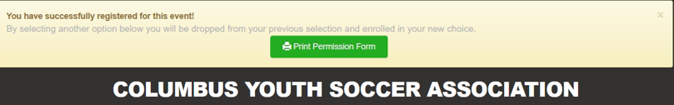

- Save a screenshot of your registration using the Print Permission Form button in the confirmation box to keep for your records. Nothing needs to be turned into your teacher or the Magnet Office.

WHAT HAPPENS NEXT?
Each agency is assigned a CHS teacher who acts as a Faculty Liaison between the volunteer coordinator and the students.
If you have selected a SUMMER ONLY opportunity or would like to get started volunteering before August, you need to directly contact the Faculty Liaison for your agency (see below for a complete list).
If you plan to start your community service in August or later, Community Service Informational Meetings will be held once the 2026-2027 school year has begun.
  - Meeting dates/times will be posted in the daily announcements or through student email. It is your responsibility to check the announcements/email and attend your agency’s meeting. During the meeting, you will learn the requirements of the agency, appropriate dress, etc., as well as, how to sign up for the dates and times to volunteer.
Documenting your hours: Service hours should be logged on the Community Service Log Sheet.
  - Blank paper copies of the 2026-2027 log sheet can be found in a basket outside the Magnet Office door.
  - Digital forms can be found online via the school website by selecting the Community Service icon and clicking the link in this document.
  - Once you have completed all 20 hours of your community service requirement, have the volunteer coordinator sign and complete the bottom portion of the form. You do not have to wait until the April 30, 2027 deadline.

COMMUNITY SERVICE FAQs
Who do I contact to ask questions about my community service agency?
All questions specific to the community service agency should be directed to the Faculty Liaison. If you are reaching out over the summer, please keep in mind teachers are technically not on contract and might not be checking their school email on a daily basis. Please allow time for a response. Better yet, contact the teacher liaison for any information you might need BEFORE school gets out. Questions pertaining to general community service requirements or issues should be directed to the Magnet Office.
Can I change my community service agency after registration closes?
Students are not allowed to change agencies once registration is closed. Many of these agencies depend on our students to operate their programs. Therefore, it is imperative that students fulfill their obligation.
Can I volunteer during school hours?
Students are not allowed to miss school in order to complete volunteer hours. Hours should be completed before/after school or during school holidays and breaks.
What is the deadline for completing the summer community service requirement?
Community service hours should be completed June 1,2027-July 31, 2027.
What happens if I do not complete my hours before the deadline?
Students who do not submit a completed log sheet by April 30, 2027 will receive a Magnet Probation Contract letter which requires signatures by both the student and parent/guardian and returned to the Magnet Office. The contract states that students must complete the current community service requirement in order to receive their schedule for next year. Students who do not meet the requirement by the first day of school will advance to a Magnet Behavior Contract/Step 1 of Revocation.

