Summer Reading Assignment 2026:
9th Grade Honors Literature and Composition

STUDENT INSTRUCTIONS (*please read carefully)
- Students will read one (1) novel and analyze it with the accompanying Major Works Data Sheet (MWDS). It is important to annotate as you read.
- DUE DATE: You should download AND save an electronic copy of your MWDS. Be prepared to submit your electronic MWDS to Canvas during the first week of school. Your English teacher will give you instructions for this in class.
- You may be asked to complete assignments with your summer reading book, such as discussions, an in-class timed writing, and/or a final project.
- You will need to be completely familiar with the plot, the characters, and the literary devices in your novel!
- LATE WORK POLICY: Any and all work that is not submitted by the due date and time will incur a 20% late penalty. If the late work is not submitted within 3 days of the original due date, the summer work will be recorded as a zero in the grade book.
- PLAGIARISM POLICY: Any student found guilty of plagiarism and/or AI usage will receive a zero (0) for the assignment, will have their parents contacted, will be referred to the honor council, and will be stripped of any academic honors for a full calendar year. WARNING: Avoid copying another student’s work or copying and pasting from sites such as Sparknotes, Enotes, and Bookrags, as this will warrant consequences for plagiarism.

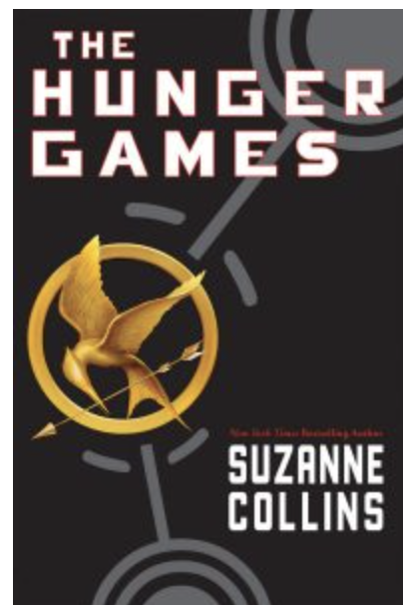
”In a not-too-distant future, the United States of America has collapsed, weakened by drought, fire, famine, and war, to be replaced by Panem, a country divided into the Capitol and 12 districts. Each year, two young representatives from each district are selected by lottery to participate in The Hunger Games. Part entertainment, part brutal intimidation of the subjugated districts, the televised games are broadcasted throughout Panem as the 24 participants are forced to eliminate their competitors, literally, with all citizens required to watch. When 16-year-old Katniss's young sister, Prim, is selected as the mining district's female representative, Katniss volunteers to take her place. She and her male counterpart, Peeta, the son of the town baker who seems to have all the fighting skills of a lump of bread dough, will be pitted against bigger, stronger representatives who have trained for this their whole lives.” from– The School Library Journal

*I would recommend getting a hard copy of the book so that you can annotate properly; however, you are welcome to borrow from your public library and use sticky notes instead. Even if you’ve read it before, read it again with a critical eye.

Major Works Data Sheet

NAME: Period:
Title  Author  Date of Publication  Genre | Biographical information about the author (you may use the internet to find this information–put it in your own words and write the website you used–avoid SparkNotes, eNotes, etc.)
Historical Information about the time period the author was in when they wrote this novel | 5 Vocabulary words & definitions that you did not know
Memorable Quotes (Minimum of 3) use MLA in-text citation: (Authorlstname pgnumber); ie (Brooks 26)  a.  b.  c. | Significance of each Quote (What does it mean? Why is it important?)  a.  b.  c.
List Characters (Designate them as major and minor/protagonist or antagonist?) | Description of characters (words/phrases that tell us what they look like and helps us understand their personality)
Setting (time/place) | Why is the setting important to the novel?
Symbols (find at least 3)--what is the object? | Significance of symbols-What does the object mean/stand for?
Possible Themes (message we get from the text as a whole)---Topics of Discussion | Discuss the most important theme:

You will want to annotate (write notes) in the pages of your novel for the following:

- Vocabulary—see some suggestions below:
  - Any words you need to look up that Collins creates for the world, and/or any that are used in a new and interesting way.
- Characters—
  - Pick 1 character: annotate 5 incidents that involve your character; quotes in which the author makes direct statements about the character; what did you infer about the character that may not have been directly stated?
- Foreshadowing
  - Find clues revealing what will happen later in the story.
- Themes
  - What do you learn about people, society, or yourself after reading this book?
- Conflicts
  - Internal vs external (human vs human, human vs nature, human vs themself)

