Honors American Literature
Summer Reading assignment
Columbus High school
liberal arts college preparatory magnet
2025-2026 school year

HONORS AMERICAN LITERATURE SUMMER READING LIST
The purpose for summer reading in Honors American Literature is to prepare you for the level of reading, writing, and thinking that is the hallmark of this course. You will complete writing assignments for Ray Bradbury’s Fahrenheit 451. This classic novel explores themes regarding the dangers of censorship, technology, and the suppression of knowledge. It contains a powerful warning about the potential consequences of a society that prioritizes entertainment and mindless consumption over critical thinking and individual expression.

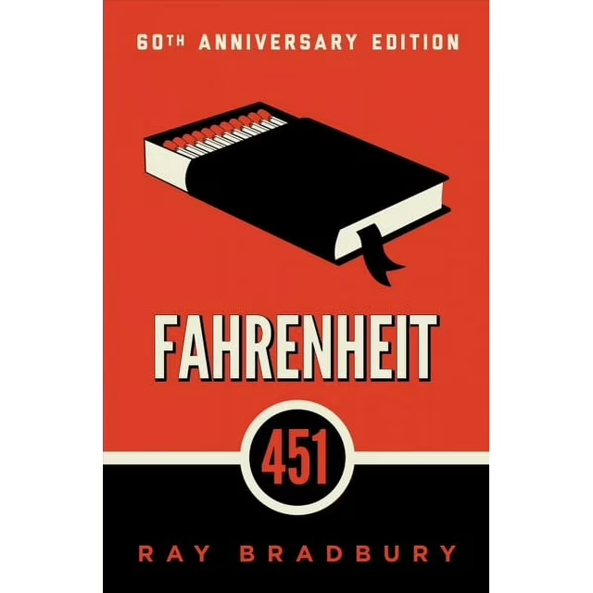
Brief Synopsis
- Fahrenheit 451 by Ray Bradbury
“In Fahrenheit 451, Guy Montag, a fireman in a dystopian society where books are illegal and burned, begins to
question his role after meeting Clarisse, a young woman who introduces him to the world of literature and
independent thought. As he delves into the forbidden world of books, Montag experiences a transformation,
becoming disillusioned with his job and the oppressive society he lives in

As you read the novel, make sure that you annotate (write notes, questions, highlight, etc.) meaningful passages and unfamiliar vocabulary. WRITE in your book, or if you read the novel online, write notes on paper. This will help with your overall understanding of the book.

Your writing assignment will be electronically submitted to the Canvas database on Monday, August 1, 2025. Work is due during your designated ELA class period. Any work submitted after the class period is deemed late work and will incur a penalty. You will only have one day to submit a late assignment. Afterward, no late work will be accepted. The Turnitin.com program will be used to assess plagiarism, so similarity should not exceed 20%. Points will be deducted for any percentage that surpasses that amount. Student work should be authentic, so please review the CHS policy on plagiarism to ensure that your entry is satisfactory.

- Character Descriptions: Identify the following 6 characters and briefly describe both their qualities and notable deeds throughout the novel. One question to consider: Does this character embody the values of this futuristic world, or does he/she stand in opposition to those values? Perhaps he/she starts out one way but ends up another. (If so, explain that.) Remember, these discussions must be entirely your own. Write 3-5 complete sentences for each character. Include textual evidence that includes vivid detail; be sure to list page numbers.

- Montag
- Clarisse
- Mildred
- Beatty
- Faber
- Granger

- Bradbury as Prognosticator: Considering that Ray Bradbury published this novel in 1951, some say the author was a brilliant visionary. Examine six features of modern life (listed in the graphic organizer on side 2 of this document) that are present in the novel and, arguably, are abundantly present in our society today. Bullet at least 4 examples in each box (4 specific examples from the novel, and 4 examples witnessed in today’s society.) Include paper numbers along with the textual evidence that you use. Add paper if needed. (No other writing is required for this one-just the completed graphic. During Unit Zero, you will use your notes for timed writing and class discussion.

Bradbury as Prognosticator: Features of Modern Life in Fahrenheit 451 and in today’s world

Features | 4 specific examples of this feature in the novel-MEANINGFUL BULLETS ONLY | 4 specific examples of this feature in America today-MEANINGFUL BULLETS ONLY
1 Fast pace of life/short attention spans

2 Violence/diminished value for human life

3 Emphasis on shallow entertainment

4 Diminished value for knowledge and education

5 Diminishment of quiet pursuits and family life

6 Prevalence of technology, with dehumanizing effects

