CHS Summer Math Packet
All incoming freshmen are required to complete summer math assignments. To access these assignments, go to www.myopenmath.com and select register as a new student. Complete the New Student Signup information, entering the course ID and enrollment key as follows:
Course ID: 182652
Enrollment key: toinfinity

Be sure to use the name you used when registering for CHS. Successful enrollment will bring you to the CHS Summer Math Review Course (Incoming Freshmen) home page, as shown below. All instructions, resources, and assignments are provided in the online course, which will be available from May 24th at 12 AM until August 8th at 11:59 PM. All online assignments are due on Tuesday, August 8th at 11:59 PM. All supporting work must be turned in to your math teacher on Wednesday, August 9th.
No late assignments will be accepted after the online course closes.
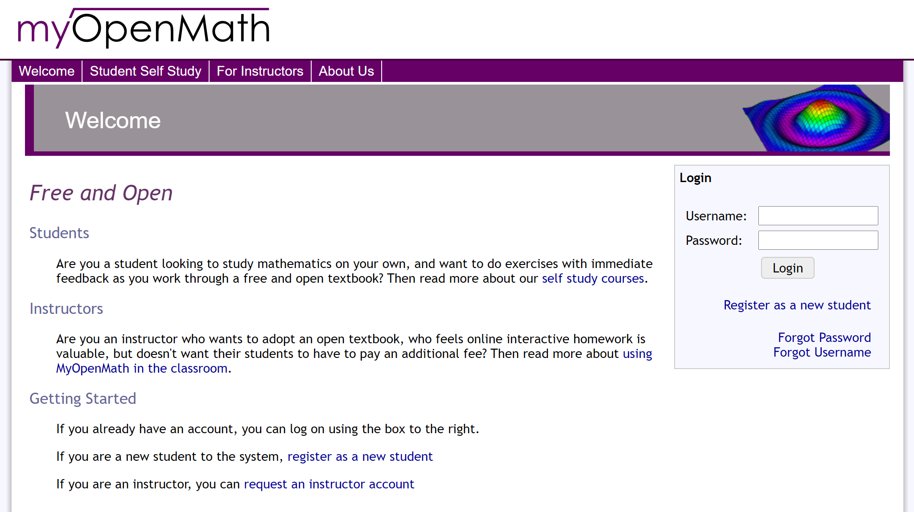

Course Homepage:
