Summer Reading Assignment 2023-2024:
Honors Twelfth Grade Multi-Cultural Literature and Composition

Our summer reading program at Columbus High School is designed to encourage students to read selections that can challenge and improve their reading comprehension. The novels and plays
create a forum for engagement in full class/group discussions. We hope each student will find these reading selections entertaining, an addition to future college reading, and an enhancement to the learning experience.

KEEP IN MIND: We will be doing some sort of review/discussion with your text when the school year starts, so as you read, highlight, fold pages, jot notes, pinpoint passages that create the deepest meaning for you… do whatever you need so that you can go back and connect to the text when you are finished with it! We are hoping that the text you read stays with you. So again, in order for you to be comfortable with the details when school begins, take notes so you don’t spend time re-reading.

Some titles contain mature content, and as such, parents/guardians should review the choices with their children to determine the most appropriate choice.

STUDENT INSTRUCTIONS
Choose one novel (1984, Emma or The Handmaid’s Tale). A short synopsis has been given below.
Emma by Jane Austen

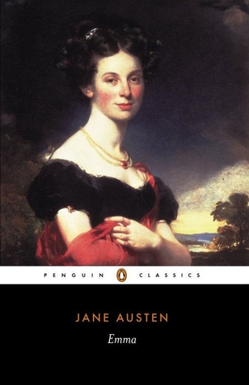
Nineteen Eighty-Four by George Orwell (novel) describes a dystopian future rife with war and one where the government—led by Big Brother—controls the truth and snuffs out individual thought. The protagonist, Winston Smith, becomes disillusioned with the Party, and he rebels against it. | Emma Woodhouse is one of Austen's most captivating  and vivid characters. Beautiful, spoilt, vain and  irrepressibly witty, Emma organizes the lives of the  inhabitants of her sleepy little village and plays  matchmaker with devastating effect. …

The Handmaid’s Tale-Margaret Atwood 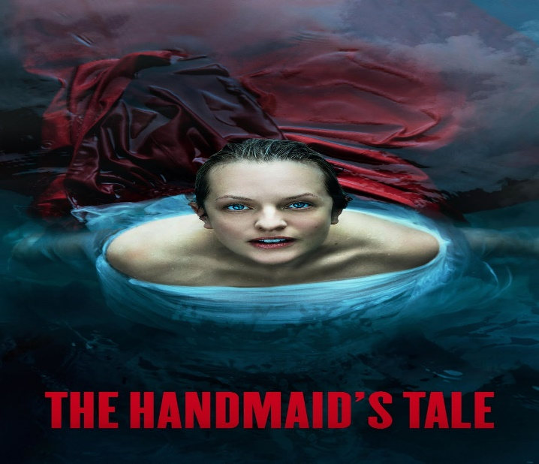

Offred is a Handmaid in the Republic of Gilead. She may leave the home of the Commander and his wife once a day to walk to food markets whose signs are now pictures instead of words because women are no longer allowed to read. She must lie on her back once a month and pray that the Commander makes her pregnant, because in an age of declining births, Offred and the other Handmaids are valued only if their ovaries are viable. Offred can remember the years before, when she lived and made love with her husband, Luke; when she played with and protected her daughter; when she had a job, money of her own, and access to knowledge. But all of that is gone now...

Everyone must 5 chapters from Read How to Read Literature Like a Professor: Choose Only 5 chapters to read and highlight. Please make sure that you write down your chapters.

how to read literature like a professor If the hyperlink does not work, Google the title and read choose four chapters to read. Make sure that your write down the chapters that you read.

Please be prepared to discuss your reading upon returning to school.

