Summer Reading Assignment 2023:
9th Grade Honors Literature and Composition

STUDENT INSTRUCTIONS (*please read carefully)
- Students will read one (1) novel and analyze with the accompanying Major Works Data Sheet (MWDS). It is important to annotate as you read.
- DUE DATE: You should download AND save an electronic copy of your MWDS. Be prepared to submit your electronic MWDS to Canvas during the first week of school. Your English teacher will give you instructions for this in class.
- You may be asked to complete assignments with your summer reading book, such as discussions, an in-class timed writing, (turning it into polished final draft), and/or a final project.
- You will be able to use ONLY your MWDS on the in-class writing, not the novel or any other notes. Be completely familiar with the plot, the characters, and the literary devices in your novel!
- LATE WORK POLICY: Any and all work that is not submitted by the due date and time will incur a 25% late penalty. If the late work is not submitted within 3 days of the original due date, the summer work will be recorded as a zero in the grade book.
- PLAGIARISM POLICY: Any student found guilty of plagiarism will receive a zero (0) for the assignment, will have their parents contacted, will be referred to the honor council, and will be stripped of any academic honors for a full calendar year. WARNING: Avoid copying another student’s work or copying and pasting from such sites like: Sparknotes, Enotes, and Bookrags, as this will warrant consequences for plagiarism.

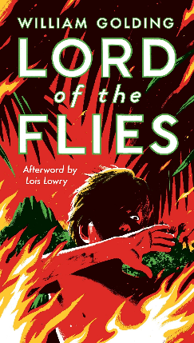
At the dawn of the next world war, a plane crashes on an uncharted island, stranding a group of schoolboys. At first, with no adult supervision, their freedom is something to celebrate. This far from civilization they can do anything they want. Anything. But as order collapses, as strange howls echo in the night, as terror begins its reign, the hope of adventure seems as far removed from reality as the hope of being rescued.

*I would recommend getting a hard copy of the book so that you can annotate properly; however, I have included this link for you to read online. You will have to create your own annotation system. https://www.depaulcatholic.org/pdfs/flies.pdf

Major Works Data Sheet

NAME: Period:
Title  Author  Date of Publication  Genre | Biographical information about the author
Historical information about the time period of the story | 5 Vocabulary words & definitions that you did not know
Memorable Quotes (Minimum of 3)  a.  b.  c. | Significance of each Quote  a.  b.  c.
List Characters (major and minor/protagonist or antagonist?) | Description of characters (words/phrases)
Setting | Why is the setting important to the novel?
Symbols  The Conch  Signal Fire  “Beastie” | Significance of symbols
Possible Themes ---Topics of Discussion | Discuss the most important theme:
You will want to annotate (write notes) in the pages of your novel for the following:

- Vocabulary—see some suggestions below:
  - Efflorescence (12), ebullience (38), vicissitudes (49), declivities (54), leviathan (105), impervious (121), demure (133), corpulent (146), parried (179), talisman (180), acrid (186), epaulettes (200)
- Characters—major: Ralph, Jack, Piggy
  - Pick 1 character: annotate 5 incidents that involve your character; quotes in which the author makes direct statements about the character; what did you infer about the character that may not have been directly stated.
- Foreshadowing
  - Find clues revealing what will happen later in the story.
- The 6 Hunts
  - Evaluate each of the hunts as to what negative occurred during or following it.

