Summer Reading Assignment 2022-2023:
Honors Twelfth Grade Multi-Cultural Literature and Composition

Our summer reading program at Columbus High School is designed to encourage students to read selections that can challenge and improve their reading comprehension. The novels and plays
create a forum for engagement in full class/group discussions. We hope each student will find these reading selections entertaining, an addition to future college reading, and an enhancement to the learning experience, .

KEEP IN MIND: We will be doing some sort of activity with your text when the school year starts, so as you read, highlight, fold pages, jot notes, pinpoint passages that create the deepest meaning for you… do whatever you need so that you can go back and connect to the text when you are finished with it! We are hoping that the text you read stays with you. So again, in order for you to be comfortable with the details when school begins, take notes so you don’t spend time re-reading.

*Disclaimer: A few of the works may contain some adult language and content, If needed, feel free to ignore the expletive and replace with another milder term in your mind.

STUDENT INSTRUCTIONS
Choose one novel (1984 or Brave New World), and then read the play listed below. Everyone must read the play.

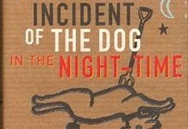
Nineteen Eighty-Four by George Orwell (novel) describes a dystopian future rife with war and one where the government—led by Big Brother—controls the truth and snuffs out individual thought. The protagonist, Winston Smith, becomes disillusioned with the Party, and he rebels against it. | The Curious Incident of the Dog in the Night-Time (by Mark Haddon) tells the story of Christopher Boone’s investigation that leads him to uncover a variety of family secrets and eventually struggle against the personal, developmental limitations on his independence. In the novel’s opening scene, Christopher finds the body of Mrs. Shears’ poodle, Wellington, with a garden fork stuck through its body. This gruesome discovery becomes the plot’s inciting incident, as Christopher makes it his mission to discover who murdered Wellington

The Hate U Give by Angie Thomas
Sixteen-year-old Starr Carter moves between two worlds: the poor
neighborhood where she lives and the fancy suburban prep school
she attends. The uneasy balance between these worlds is shattered
when Starr witnesses the fatal shooting of her childhood best
friend Khalil at the hands of a police officer.
Emma by Jane Austen
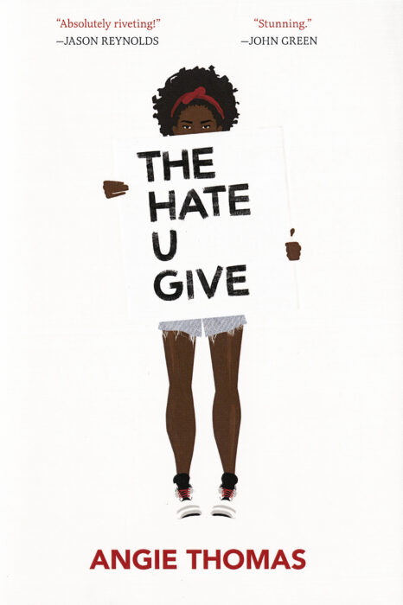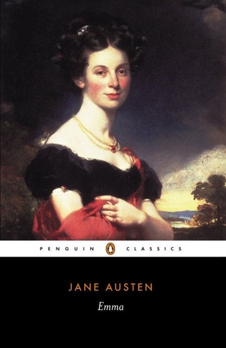

Emma Woodhouse is one of Austen's most captivating
and vivid characters. Beautiful, spoilt, vain and
irrepressibly witty, Emma organizes the lives of the
inhabitants of her sleepy little village and plays
matchmaker with devastating effect. …

play: THE MISER. (L'AVARE.) BY MOLIERE TRANSLATED INTO ENGLISH PROSE WITH A SHORT INTRODUCTION AND EXPLANATORY NOTES. BY CHARLES HERON WALL.
the-miser.pdf - Cold Reads/International
Book Project Instructions
Using the book (novel) of your choice, (the novel that you decided to read) pick one
Of the following projects to complete. Projects are expected to be completed by the second week of school
August 15, 2022.

Option 1: Movie Poster

Design a movie poster of your favorite scene in the book. Posters can be done by hand or using a digital platform. Use any art supplies necessary for completion and be as creative as possible! Posters should be standard poster size (22 x 28). This project must be done individually (alone)
REQUIREMENTS:
1. Your poster must contain original art to represent the main idea of the story. You need at least one main
Graphic/scene but may choose to include more.
2. Must be in full color. No pencil or ink!
3. Title of story and author’s name must be clearly visible on the front, your name on the back
4. At least two “review” quotes from a critic about the story. This should be made-up (or you can Google
the reviews) and is intended to draw the viewer’s interest. No more than 2 sentences per review.
5. Include a “tagline” for the story. This should act as a “teaser”—make it short and catchy.
6. You must have a 5 complete-sentence summary explaining the visual. Attach to your poster (this must
be typed, Times New Roman, font 12, single spaced back or typed and pasted)
7. Name famous people to play the parts of the two or three primary characters of the novel.
8. What star rating would you give the movie (1 = lowest – 5= highest)
7. Be creative and have fun with this!

Examples of movie taglines:
- Tommy Boy. "If at first you don't succeed, lower your standards." ...
- Chicken Run. "Escape or die frying." .
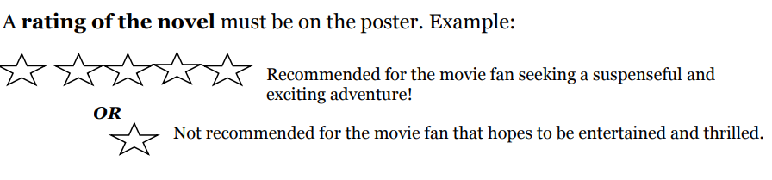
DO NOT COPY THE BOOK COVER

********************************

Sample Book Cover for Option 1
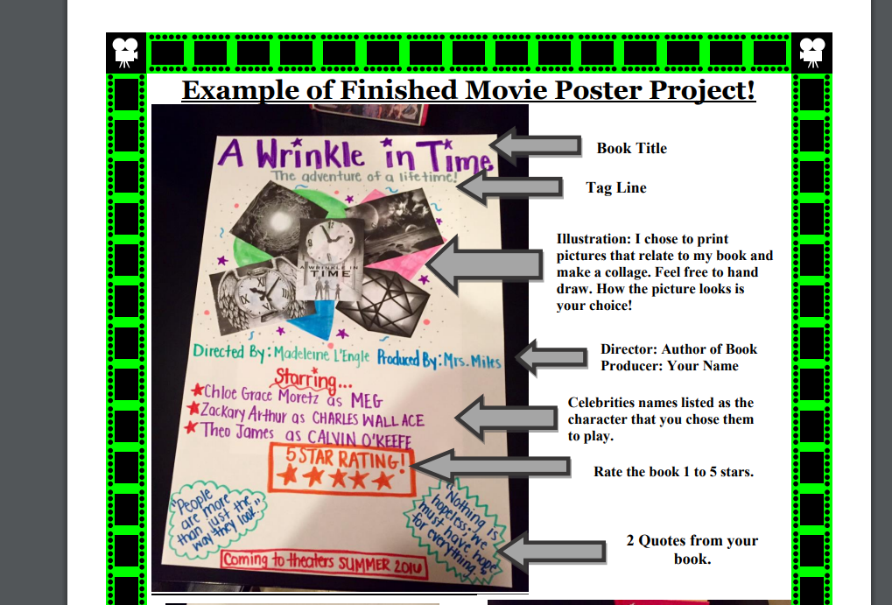
Option 2: Digital Presentation
Create a digital presentation that informs others about your book. This project can be completed alone/ (individual project) or as a group project. No more than 4 members per group. Each member of the group must have a speaking and acting role in the video. Members must captured in the video in some way.

Book Trailer Instructions:
What is a book trailer? A "trailer" is a brief video synopsis of a book or movie, designed to entice viewers to see
the entire work. Your job is to create a Book Trailer for the novel your group read for independent reading.

Assignment Description for Option 2:
Individually or with your group (4), you will be responsible for creating a book trailer. Your book trailer should
include:
- Brief introduction to setting, main characters
- Brief synopsis of story, or exciting scene(s)
- Use of images, sound in the video
- A leading question for the viewer to ponder (possibly entice them to read the book!)
- Overall time of trailer (1-2 min)
- Name of the book and the author and the time period in the novel.
- Names of group members placed at the end of the video
- A hook to pique your audience’s interest (make us want to read the book and complete the trailer)
- Credits for sound and pictures, etc.
- Have fun with this project, but do not include any thing that is questionable.
Be sure to consider the following elements:
• Make sure text size, font and contrast are easy to read
• Speed of information (images, text, etc.) are paced appropriately

*Save your presentation and be prepared to upload to Canvas during the first week of school.

Sample Book Trailers
https://youtu.be/AOe13IaA7Ws
https://youtu.be/RNL77KnIRI8

Reading Notice:
In an ongoing effort to recognize the widening cultural horizons of literary works written in English, the English department will consider and include diverse authors in the representative reading lists. Issues that might, from a specific cultural viewpoint, be considered controversial, including references to sex, sexualities, ethnicities, nationalities, religions, races, dialects, gender or class, are often represented artistically in works of literature. The department is committed to careful review of such potentially controversial material. Still, recognizing the universal value of literary art that probes difficult and harsh life experiences and so deepens understanding, the committee emphasizes that fair representation of issues and peoples may occasionally include controversial material.
As seniors and potential college students literature depends on a level of maturity consistent with the age of 12th-grade students who have engaged in thoughtful analysis of literary texts. The best response to a controversial detail or idea in a literary work might well be a question about the larger meaning, purpose or overall effect of the detail or idea in context. Seniors should have the maturity, the skill and the will to seek the larger meaning through thoughtful research. Such thoughtfulness is both fair and owed to the art and to the author.

Our summer reading program at Columbus High School is designed to encourage students to read selections that can challenge and improve their reading comprehension. . We hope each student will find these reading selections entertaining and an enhancement to your summer experience.

The goals of summer reading are to encourage students to read, improve their reading skills, and have knowledge of authors. The data conclusively demonstrates that students who regularly read are better academic achievers and, for that reason, summer reading is essential.
Students enrolled in Multicultural literature are required to complete summer reading and assignments for the upcoming school year.

Rewrite the Ending

Your assignment is to rewrite the last chapter for the book you have chosen to read. Rewrite the
ending of the story, changing what happens. Your new ending must be original, credible, and
realistic for your book. For example, if your novel is set during World War II, you cannot introduce
vampires as new characters in the book. You cannot change any events that have already happened
previous to your new ending.

Your new ending chapter must:
• Be written in the same style and tone as the author
• Include the use of dialogue and demonstrate proper use of quotation marks
• Be at least 2 typed, double-spaced pages using 12-point font and 1" margins

In addition, you must include a paragraph fully explaining why you chose to change the ending the
way you did and why this new ending is plausible for your book.

