AP Literature and Composition
Summer Reading Assignments
2022-2023

Ms. J. Williams & Mr. Ginn
Ginn.Charles.W@muscogee.k12.ga.us
Williams.Jacqueline.A@muscogee.k12.ga.us

AP Literature and Composition Students:
Advanced Placement (AP) Literature and Composition is designed to present you with an in-depth study of great literature from around the world. Through this course, you will hone your ability to read closely and think critically about texts from different genres, time periods, and canons. This is a college-level class with college-level requirements. In May, 2023, you will have the opportunity to earn college credit by taking the Advanced Placement examination in English Literature and Composition. Enrollment in this course indicates that you have already demonstrated a high achievement level in the analysis of literature, a superior writing ability, and a motivation to do college-level work in high school.
We are very excited about teaching AP Literature and Composition next year! As we have a great deal of work to do this upcoming year, your course will actually begin over the summer. The summer reading assignment is an important feature of the AP Literature and Composition course, and it serves two functions: 1) to keep you active as readers, and 2) to exercise your critical thinking muscles. This important requirement will ease your transition into your senior year.
Listed below are the required texts and directions for completing the summer reading assignment:

Required Reading
Everyone must read the following common text:
How to Read Literature like a Professor, Thomas C. Foster
Everyone must read one of the following novels below:
All the Light We Cannot See, Anthony Doerr
The Poisonwood Bible, Barbara Kingsolver
Purple Hibiscus, Chimamanda Adichie
The Joy Luck Club, Amy Tan
Where the Crawdads Sing, Delia Owens

AP Lit. Summer Reading Menu
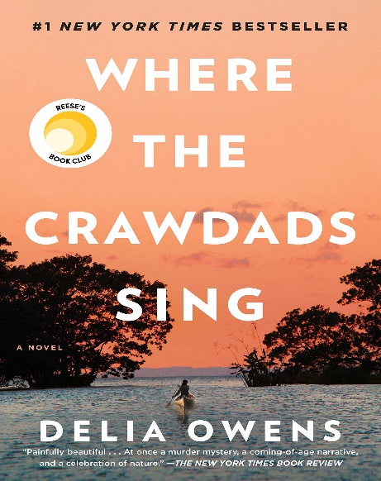
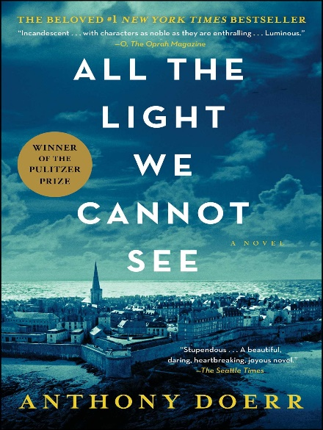

Description of Novel: For years, rumors of the "Marsh Girl" have haunted Barkley Cove, a quiet town on the North Carolina coast. As such, in late 1969, when handsome Chase Andrews is found dead, the locals immediately suspect Kya Clark, the so-called Marsh Girl. But Kya is not what they say. Sensitive and intelligent, she has survived for years alone in the marsh that she calls home, finding friends in the gulls and lessons in the sand. Then the time comes when she yearns to be touched and loved. When two young men from town become intrigued by her wild beauty, Kya opens herself to a new life—until the unthinkable happens.
Description of Novel: This work of historical fiction is a tantalizing story of two characters whose paths will intersect in the waning days of World War II: an orphaned engineering prodigy recruited into the Nazi ranks, and a blind French girl who joins the Resistance. Tackling questions of survival, endurance and moral obligations during wartime, the book is as precise and artful and ingenious as the puzzle boxes the heroine’s locksmith father builds for her.

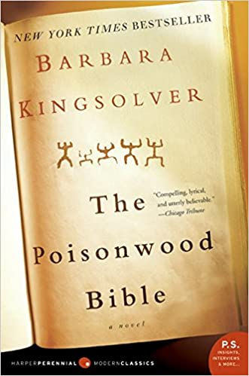

Description of Novel: Set in postcolonial Nigeria, Purple Hibiscus is narrated by Kambili Achike, a 15-year-old who finds her voice as she begins to question first her father, then everything. Kambili’s dad, a rich scion, is a brave champion of free speech, but he’s also a meticulous, authoritarian patriarch. Kambili’s understated tone cushions the blows of the violence she describes both inside and outside her home. Chimamanda Ngozi Adichie’s first novel is lush with telling detail about her native country, homing in on the contrasts between rich and poor, young and old, and delivering sharp truths about power and freedom.
Description of Novel: The Poisonwood Bible is a story told by the wife and four daughters of Nathan Price, a fierce, evangelical Baptist who takes his family and mission to the Belgian Congo in 1959. They carry with them everything they believe they will need from home, but soon find that all of it—from garden seeds to Scripture—is calamitously transformed on African soil. What follows is a suspenseful epic of one family’s tragic undoing and remarkable reconstruction over the course of three decades in postcolonial Africa.

AP Lit. Summer Reading Menu (Continued)
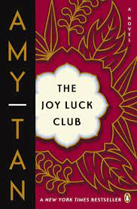
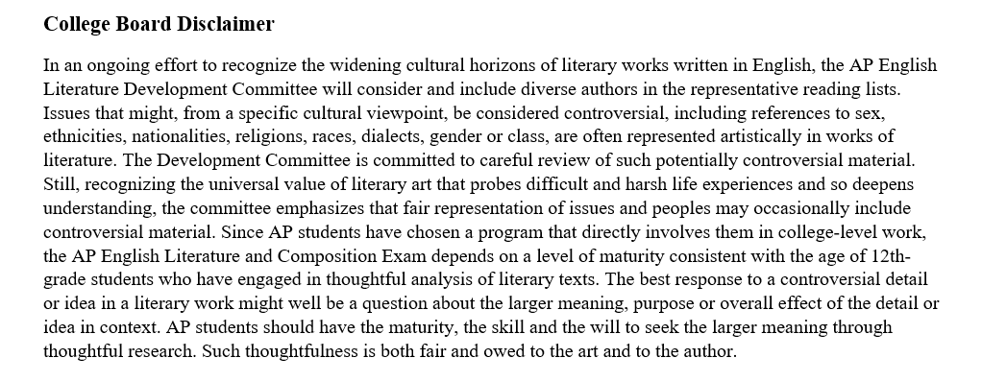
Description of Novel: Four mothers, four daughters, four families, whose histories shift with the four winds depending on who's telling the stories. In 1949, four Chinese women, recent immigrants to San Francisco, meet weekly to play mahjong and tell stories of what they left behind in China. United in loss and new hope for their daughters' futures, they call themselves the Joy Luck Club. Their daughters, who have never heard these stories, think their mothers' advice is irrelevant to their modern American lives – until their own inner crises reveal how much they've unknowingly inherited of their mothers' pasts.

How to Read Literature Like a Professor Application Assignment:
Thomas Foster’s How to Read Literature Like a Professor (HTRLLAP) is an excellent primer on how to plumb the depths of literary meaning beyond surface-level narrative concerns. Indeed, Thomas’s text urges you to turn away from performing distant readings of literary works by giving you the tools needed to perform nuanced, close reading of literary texts. Over the course of his work, you will proceed through twenty-seven chapters that present different case studies in how to attend to larger figurative, archetypal, symbolic, and socio-political implications of a text, ones that will provide you with interpretative frameworks for approaching future works of literary fiction.
Directions:
In order to complete the HTRLLAP application assignment, you must first read both HTRLLAP and one of the novels of your choice above. The novel that you pick is totally up to you; pick one that speaks to you! Then, you must apply three different HTRLLAP chapter concepts to your chosen novel by completing three total application papers. In each application paper, you will isolate a specific moment in the novel, apply a single chapter from HTRLLAP to that moment, and suggest how the concept presented in HTRLLAP can help us better understand that moment. In order to get full credit, each application paper must summarize a moment from the novel using textual evidence, explain a concept from HTRLLAP using textual evidence, and suggest how HTRLLAP can help us unpack the “deeper meaning” in the moment from the novel. You cannot talk about the same moment from your novel more than once, nor can you cite a HTRLLAP chapter more than once. Each application response paper should be 500-750 words, double-spaced, and written in accordance with MLA documentation style. In these application papers, your voice should be formal, academic, and polished.
HTRLLAP Application Paper Requirements
Genre of Writing | Length | Style
3 Textual Evidence-Based Application Papers | 500-750 Words Each (1½-2 Double-Spaced Pages) | MLA

HTRLLAP Application Paper Components
- Introduce a moment or scene from your novel.
  - When summarizing this scene, you must describe it specifically by grounding it in textual evidence.
    - At least one quote is required.
- Introduce a relevant chapter from HTRLLAP.
  - When summarizing this chapter, you also must describe it in detail by grounding it in textual evidence.
    - At least one quote is required.
- Suggest how the concept from HTRLLAP can help to better unpack the figurative, archetypal, symbolic, or socio-political value in the moment/scene.
- While you do not need any quotes in this section of your paper, this commentary is the most important part of the paper and should be multiple sentences long.

CHS Student
Mr. Ginn
AP Literature and Composition
5 May 2022

HTRLLAP Application Paper Exemplar: Mythic Influence in Tennessee Williams’s
A Streetcar Named Desire
Famously, Tennessee Williams’s play, A Streetcar Named Desire, opens with Blanche Dubois, the central character of the piece, convinced that she has arrived at the wrong location. After losing her family’s large estate, Belle Reve, because she defaulted on the mortgage, she arrives in the French Quarter of New Orleans to stay with her sister and brother-in-law, Stella and Stanley Kowalski. Even though she is seeking refuge and hospitality, her deeply engrained aristocratic sensibilities cause her to “turn up her nose” at Elysian Fields, the modest, working-class neighborhood where she must stay with her relatives. In fact, upon first arriving at the location, she asks Eunice, one of the neighborhood denizens, where Elysian Fields is located, which Eunice responds to by stating “this here is Elysian Fields” (Williams 6). Shocked and in disbelief at the revelation, Blanche mutters “they mustn’t have—understood—what number I wanted” as “this can’t be [my sister’s] home” (Williams 6). Due to Blanche’s genteel upbringing and her elitist nature, this scene could be understood superficially as profound culture shock that creates a bit of a comedic situation. Blanche, after all, is the proverbial fish out of water, floundering about in a new place that she considers raffish, de-classe, and beneath her.
Understanding this opening moment of the play in just this way, however, misses the mythical underpinnings of the scene. For as Thomas C. Foster explains in chapter nine “It’s Greek to Me” in How to Read Literature Like a Professor, individuals possess the need to “explain ourselves to ourselves in ways that physics, philosophy, mathematics, and chemistry…can’t,” which leads to mythic explanations that “take the shape of stories that are deeply engrained in our group memory” (Foster 65). As he goes on to note, “when most of us think myth, we mean the northern shores of the Mediterranean between two and three thousand years ago,” specifically the ancient civilizations of “Greece and Rome” (Foster 66). As such, “Greek and Roman myth is so much a part of the fabric of our consciousness, of our unconscious really, that we scarcely notice it (Foster 66). Essentially, Foster makes the argument that since antiquity we have attempted to explain different natural phenomena through myths, which are often elaborate and fanciful stories, and these myths have filtered down through the ages, molding the culture of any given time period, especially works of literature. Moreover, he suggests that our understanding of a literary text would be strengthened if we bring these mythic understandings to bear on a work.
A reading, then, that attends to the mythic resonances in the opening moments of A Streetcar Named Desire must unpack Williams’s decision to set the play in the neighborhood of Elysian Fields. In Greek mythology, the Elysian Fields represent an idyllic, privileged tier of the afterlife where mortals related to gods, heroic warriors, and other virtuous individuals spent eternity. While the spirits of these mortals could enjoy the temperate and balmy paradise forever, they were only able to do so after death. As such, by setting his play in the neighborhood of Elysian Fields, Tennessee Williams invokes the trope of passing into the afterlife, specifically through his central character, Blanche. Although Blanche does not experience physical death during the play, she experiences societal death, as the whims of her desire cause her to become ostracized from her southern hometown, complete with its elite social circles and puritanical values. The neighborhood of Elysian Fields in the play, therefore, becomes an ironic haven of sorts into which she passes. After all, it is far from an idyllic place, and it, arguably, causes Blanche to experience even greater turmoil and strife as the play progress. It, nevertheless, represents a terminus, or fixed end point, for Blanche. Just as the spirts of the Greeks spent the duration of the afterlife in Elysium, Blanche’s final act is set in Elysian Fields, not for better, in this case, but for worse.

Works Cited
Foster, Thomas. How to Read Literature Like a Professor. Harper Collins, 2012.
Williams, Tennessee. A Streetcar Named Desire. New Directions Publishing Corporation, 1947.

HTRLLAP Application Paper Rubric (75pts. Total)

Application Essay 1 | Application Essay 2 | Application Essay 3 | HTRLLAP Application Paper Rubric
/5 | / 5 | /5 | Introduce a moment or scene from your novel.  - When summarizing this scene, you must describe it specifically by grounding it in textual evidence.  - At least one quote is required.
/5 | /5 | /5 | Introduce a relevant chapter from HTRLLAP.  - When summarizing this chapter, you also must describe it in detail by grounding it in textual evidence.  - At least one quote is required.
/10 | /10 | /10 | Suggest how the concept from HTRLLAP can help to better unpack the figurative, archetypal, symbolic, or socio-political value in the moment/scene.  - While you do not need any quotes in this section of your paper, this commentary should be multiple sentences long.
/2 | /2 | /2 | Lists Author’s Name and Title of Work
/3 | /3 | /3 | Adheres to MLA Formatting Conventions  *** In addition to being double-spaced, each application essay must have a header and title. One Works Cited page is also required.***
-5 Points |  |  | Displays One or More Persistent Grammar, Punctuation, or Mechanics Issue.  ***We conceive of a persistent issue as two or more similar errors that detract from the overall readability of a student’s writing.***
-10 Points (Per Day Late) |  |  | Not Turned-In On Time
-10 Points |  |  | Word Count Not Met  ***If the essay is severely underdeveloped (250 words or less), the teacher reserves the right to require an automatic revision, and the essay will only be eligible for the minimum passing score: Example- 53/75.***
Automatic Revision & Consequence Determined by Honor Council |  |  | Plagiarism Check Not Passed  ***If you don’t pass the turn-it-in.com plagiarism check, it is an automatic referral to honor council.***

Requirements for the First Day of AP Literature and Composition
- Bring a Digital Version of the AP Literature and Composition Summer Reading Assignment to Class for Submission.
  - Remember, you will be submitting a total of three application papers.
    - Each focuses on a different moment from your novel.
    - Each cites a different chapter from HTRLLAP.
    - Each applies the HTRLLAP chapter to the novel.
  - The assignment needs to be a final draft that meets all of the rubric requirements.
  - The assignment will be ready to submit on day one, and it must pass a plagiarism check.

- Bring Copy of HTRLLAP & Your Summer Reading Novel of Choice (Hard or Digital Copy)
  - During the opening weeks of our class, we will be reviewing HTRLLAP and using our respective novels as vehicles through which to illustrate the chapter concepts.

- Be Prepared to Discuss Both HTRLLAP & Your Novel of Choice.
  - Activities during the first week will include small and large group discussions, presentations, and perhaps projects.
  - A deep familiarity with both texts will set you up for success in the opening weeks of our course.

