Advanced Placement English Language & Composition
Summer Reading assignment
Columbus High school
liberal arts college preparatory magnet
2022-23 school year

AP LANGUAGE & COMPOSITION SUMMER READING LIST:
The purpose of summer reading in AP English Language and Composition is to prepare you for the level of reading, writing, and thinking that is the hallmark of this course. The following selections are included on the approved AP Central College Board list for suggested readings for this course.
Please note the following message from College Board: “CONTROVERSIAL TEXTUAL CONTENT issues that might, from particular social, historical, or cultural viewpoints, be considered controversial, including references to ethnicities, nationalities, religions, races, dialects, gender, or class, may be addressed in texts that are appropriate for the AP English Language and Composition course. Fair representation of issues and peoples may occasionally include controversial material. Since AP students have chosen a program that directly involves them in college level work, participation in this course depends on a level of maturity consistent with the age of high school students who have engaged in thoughtful analyses of a variety of texts. The best response to controversial language or ideas in a text might well be a question about the larger meaning, purpose, or overall effect of the language or idea in context. AP students should have the maturity, skill, and will to seek the larger meaning of a text or issue through thoughtful research” (AP.CollegeBoard.org).
ABOUT PLAGIARISM:
Please keep in mind that all of your assignments should be YOUR original work and your work ALONE. Do NOT be tempted to share answers with another student or plagiarize from the internet because it will be easily detected in the turnitin.com website. Should any student(s) be found guilty of plagiarizing or copying another student’s work, he or she will receive a zero on the summer reading assignment, will have his or her parents contacted, will receive permanent documentation on his or her school transcript, will be stripped of any academic honors for a full school year, and will appear before the CHS Honor Council for further disciplinary action. As our school motto reads, “Commitment, Honor, and Success,” we expect your work to mirror our desire for your personal success and academic excellence.

An overview of your reading and writing assignments are as follows:
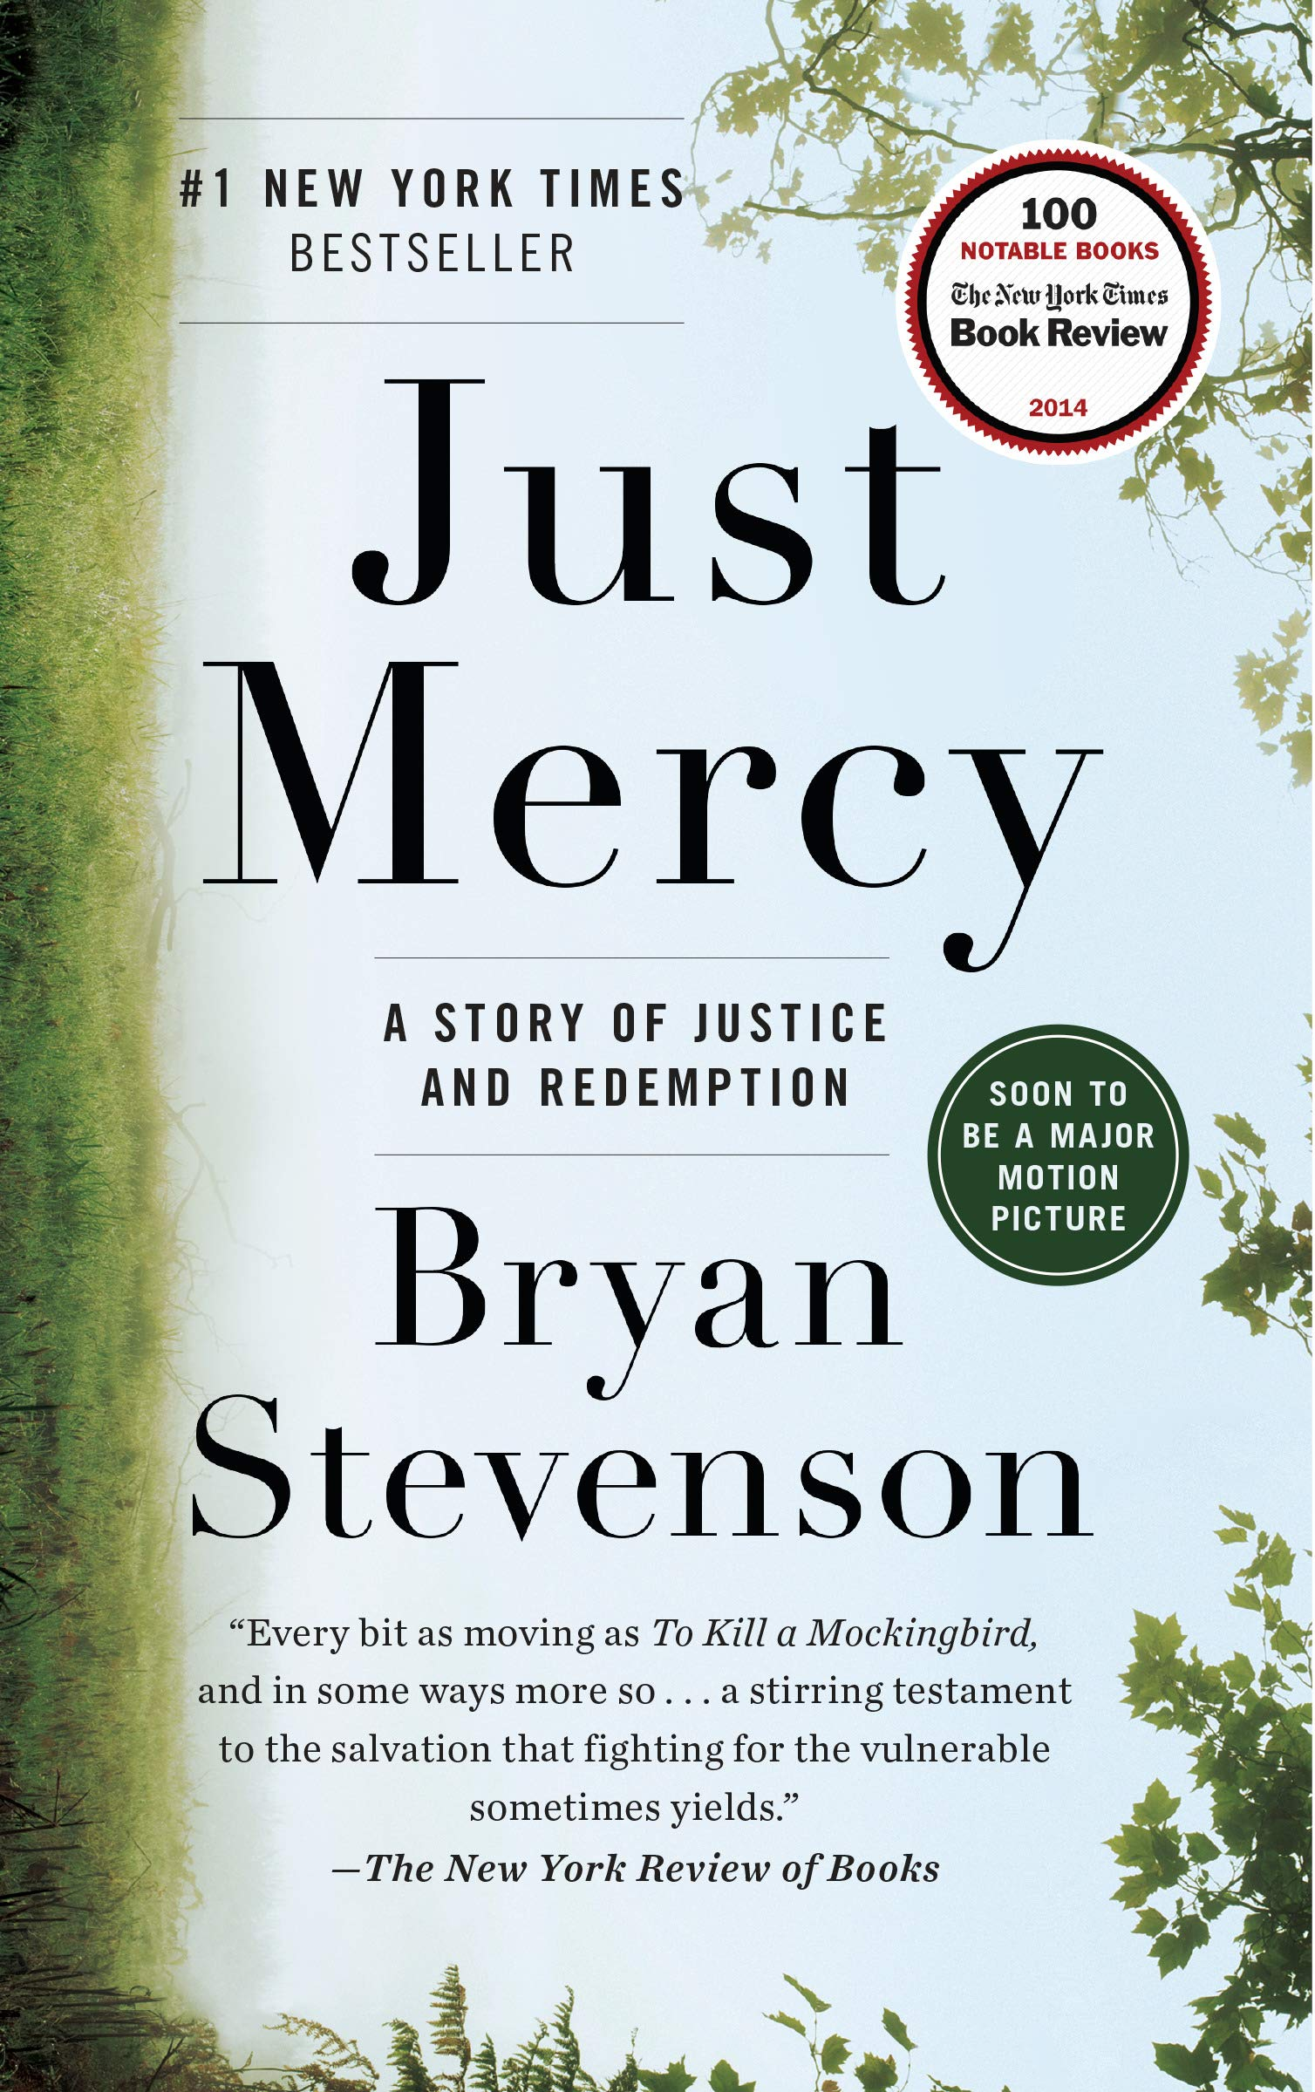
* Just Mercy: A Story of Justice and Redemption by Bryan Stevenson
(Do not read the young adult version).

For this memoir, complete the reading and writing assignment by Aug. 8, 2022. Make sure you annotate write notes, questions, highlight, etc.) as you read. WRITE in your book, or write
separate chapter notes as you read. This will assist with your overall comprehension of the book. You will have a 50-point writing assignment to complete by the first day of school,
Monday, Aug. 8, 2022. Your writing assignment must be typed and saved to be submitted on the first day of school – Monday, Aug. 8, 2022 to your AP Lang teacher. Any work not submitted on the due date will incur a 50% penalty and will not be accepted after Tuesday, Aug. 9,2022. Furthermore, you will need to save your journal assignment in a Word or Google document as it will need to be uploaded to the turnitin.com database during the first week of school. Your journal assignment will not be graded until it is submitted to the turnitin.com database to check for plagiarism; thus, if you have not saved your document, you will receive a 0 for this assignment.

Parents & Students: Please feel free to contact Lisa Mills or Shannon Williamson via email at
Mills.Lisa.K@muscogee.k12.ga.us/Williamson.Shannon.r2@muscogee.k12.ga.us
with any questions or concerns you may have.

- Rhetorical Terms - Definitions and Examples. This is individual work, and you must complete your own work! Any work submitted which looks alike or too closely similar will be investigated for possible plagiarism/cheating. You will make flashcards defining the rhetorical terms (listed on the last page of this document). You should also learn these terms as you will be applying them during annotations. If you have difficulty understanding a term, there are many resources online to assist you with understanding. You will submit your flashcards to your AP English Language teacher on the FIRST day of class, Monday, August 8, 2022. If work is not submitted on the due date, it may be submitted on the following day for a deduction of 50%. No work will be accepted after the 2nd day. You will be tested over these terms within the first three weeks of school, so you should spend time studying and learning them in August!

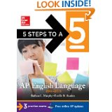
5 Steps to a 5 for AP English Language and Composition* by Barbara Murphy and Estelle Rankin.

*You will need to purchase the most current edition. Purchasing this book is required, and it will assist you in exam preparation.

JUST MERCY by Bryan Stevenson
DUE: AUG. 8, 2022 SUBMIT IN CLASS: AUG. 8, 2022

GRADING: Please be aware should you be found guilty of plagiarism (either copying or allowing someone to copy your work), you will receive a zero on this assignment. This assignment will be worth 50 points and will be submitted to the Turnitin.com website to check for plagiarism during the first week of school. Do your own individual work, and be proud of it!

A # 1 New York Times Bestseller, “Just Mercy is at once an unforgettable account of an idealistic, gifted young lawyer’s coming of age, a moving window into the lives of those he has defended, and an inspiring argument for compassion in the pursuit of true justice” (www.bn.com).

Your task is to read the novel, and complete the following critical reading and writing activities:
1. As you read, you will write a dialectical journal in which you pick 10 significant passages from the book. These passages should demonstrate your engagement with the novel; thus, they should be chosen from at least 10 different chapters of the book. You may give your personal reaction to the selected passage, discuss ideas or actions of the author or character(s), make connections, write what the passage makes you think or feel, analyze the passage and its relationship to the story as a whole, or analyze the text for the use of rhetorical devices (imagery, structure, style, tone, rhetorical appeals such as ethos, pathos, logos, diction, etc.) The purpose of the dialectical journal is to help you develop a better understanding of the text as you read. Your responses should be at least 3-6 sentences in length (required 50 words minimum).
2. Prepare your dialectical journal (via a Word or Google document) that includes the quote from the novel written in MLA format (with page number) as well as your written response in the third column.
3. Prepare your entries in a three-column format as the following model illustrates. You may NOT use the following example as one of your ten required entries. Please include your name & assignment title – Just Mercy – Dialectical Journal
Please see the sample dialectical journal as follows:
Your name:
Just Mercy Dialectical Journal
 | Quote/Passage from the novel: | Analysis & Significance:
1 | “During the talk, I noticed an older black man in a wheelchair who had come in just before the program started. He was in his seventies and was wearing an old brown suit. His gray hair was cut short with unruly tufts here and there. He looked at me intensely throughout my presentation but showed no emotion or reaction during most of the talk. His focused stare was unnerving. A young boy who was about twelve had wheeled him into the church…” (Stevenson 45). | In this passage the author’s use of imagery and details vividly captures the older gentleman in the audience. Through his descriptions, it is easy to visualize the elderly gentleman and feel the author’s apprehension as he delivers his talk. Later in the chapter when we discover even more details about this man, it seems to be a turning point in the novel for Stevenson as he realizes the need to open an office in Alabama as well as the need to continue fighting even harder for justice and reform.  (89 words)
 | - MLA format required ! Please check to make certain your quotes are formatted correctly as this will count towards your grade! You must use quotation marks & parenthetical documentation – just like the sample! | - Word count required!  - At least 3-6 sentences – minimum 50 words

GRADING FOR THIS WRITING ASSIGNMENT (50 points—5 points per entry)
In order to receive full credit, you must meet the following criteria for each entry:
1. Did you follow the correct MLA format for the quote or passage and the three-column format as shown above?
2. Did you give appropriate explanation of your reasoning for the significance of the quote with at least 3-6 sentences and at least 50 words (with word count) per entry?

UNDERSTANDING RHETORICAL TERMS
SUBMIT IN CLASS: AUGUST 8, 2022

Purpose: Knowing the following rhetorical terms will allow you to better discuss an author’s work at a more sophisticated level as you recognize the rhetorical devices an author uses to achieve his or her purpose. Throughout this course you will learn approximately 100 rhetorical terms; learning the following rhetorical terms this summer will aid you in this process.

Directions:
Rhetorical Terms Flashcards-Due the first day of school, August 8, 2022.
Define the following terms using the Internet, and you may copy definitions, or write them in your own words.
Familiarize yourself with the following terms by creating flashcards using 3x5 or 4x6 index cards. Write the term on one side, the definition and an example on the other side of the card. If you have difficulty defining or understanding a term, there are many resources online to assist you. Place a title flashcard with your first and last name and all 30 flashcards within a rubber band, and submit your flashcards to your AP English Language teacher on the first day of class, August 8, 2022. If your work is not submitted on the due date, it may be submitted on the following day for a deduction of 50%. No work will be accepted after Aug. 9, 2022. You will be tested over these terms within the first three weeks of school, so you need to be studying your flashcards!

Example: Front side of index card - Onomatopoeia
Back side of index card -A figure of speech in which natural sounds are imitated in the sounds of
words
Example: buss, hiss, crack, pop
Terms:

1. Alliteration
2. Allusion
3. Ambiguity
4. Analogy
5. Anaphora
6. Anecdote
7. Antecedent
8. Antithesis
9. Aphorism
10. Apostrophe (the figure of speech – not the punctuation mark)
11. Asyndeton
12. Chiasmus
13. Clause - (Dependent & Independent)
14. Colloquialism
15. Coherence
16. Conceit (similar to metaphor)
17. Connotation
18. Denotation
19. Diction
20. Didactic
21. Enumeratio
22. Expletive
23. Euphemism
24. Exposition
25. Extended metaphor
26. Genre
27. Homily
28. Hyperbole
29. Hypophora
30. Imagery

