You’re Invited…  to join the Columbus High School Orchestra.  Our organization provides a unique and outstanding opportunity for students to become involved at CHS. We currently have about 85 members and are looking to continue growing!  When Do the Orchestras Perform?  - Winter Concert in December  - Christmas Caroling at the Holiday Social  - Large Group Performance in March  - Spring Concert in May  - Other Special Events  Additional Orchestra Opportunities  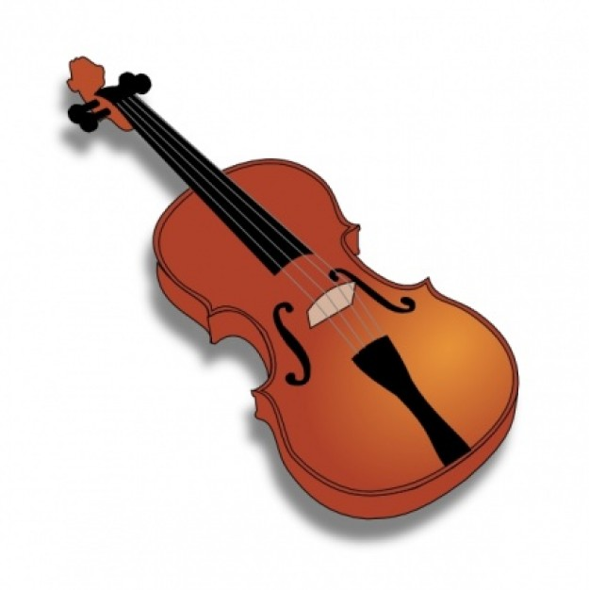  These activities are limited to students enrolled in orchestra.  - All State Orchestra  - District Honors Orchestra  - Governor’s Honors Program  - PAGE One  - Spring Trip  - Solo and Ensemble Festival  - Master classes  - Tri-M Honor Society | Why Join the High School Orchestra?  - You love to play your instrument.  - You will make new friends.  - You’ve already worked hard to develop your musical talent. High School Orchestra gives you an opportunity to continue this development.  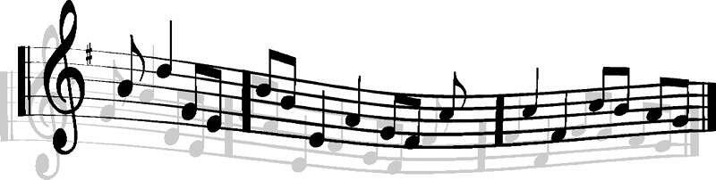  What is the Orchestra at Columbus High School?  There are two orchestras at CHS. Both groups are string orchestras that rehearse mostly during the school day. After school rehearsals are limited. No audition is required to get it, but you must have prior orchestra experience to join.  Will Orchestra Affect Participating in Sports?  - No! Almost all CHS sports are represented in the orchestras.  - Almost all rehearsals are held during the school day.  - Concerts are scheduled so sporting events don’t conflict. | Can I Fit Orchestra, and AP Courses in My Schedule?  - Yes! Orchestra students take a wide variety of electives and AP courses.  - The orchestra director and counselors will work with you to try to fit all of the classes you want into your schedule.  How Much Does It Cost?  Students do not pay a fee to join orchestra. They are required to have all essential parts for their instrument, which they should already have from middle school. In addition, students will need to have an Essential Techniques book and a concert black outfit for performances.  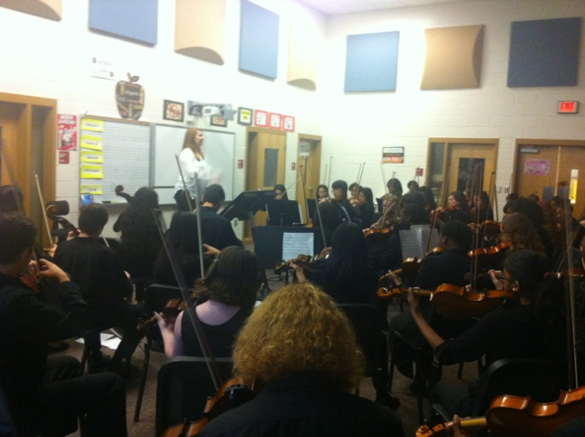
Be part of an  outstanding group!  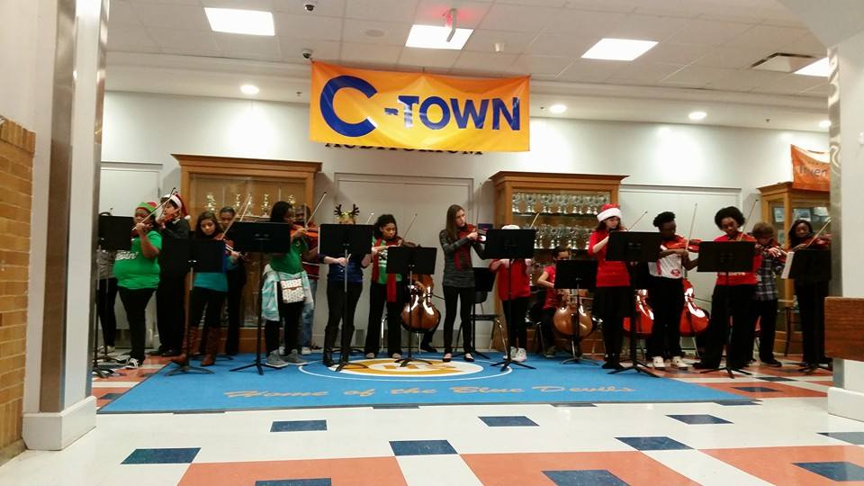  Gina Moody, Director  moody.gina.m@muscogee.k12.ga.us  1700 Cherokee Ave  Columbus, GA 31906  (706) 748-2534 | Check out our Website:  Columbushighschoolorchestra.weebly.com  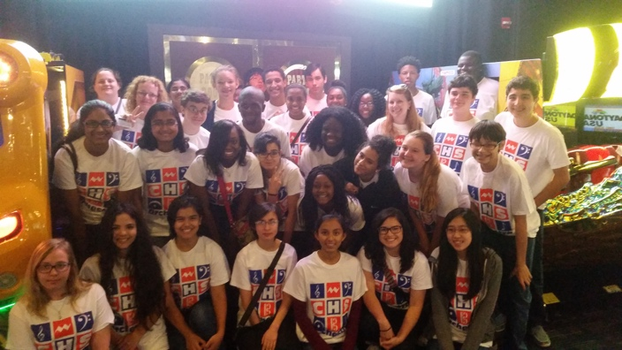 | Columbus High  School Orchestra  Superior Ratings at Large Group Performance Evaluation  All State Orchestra Students  Top chair placements in District  Honor Orchestra  Superior Ratings at the Trills and Thrill Music Festival  Superior Ratings at Solo and Ensemble

