My Payments Plus Info for CHS Parents
***THE MOST IMPORTANT UPDATE YOU NEED TO KNOW THIS YEAR>>> When you are selecting your exams to register for, it’s important that you select your STEM exam FIRST in order to get that exam at no charge. AGAIN, make sure you select your STEM exam first when registering (this only applies if you are enrolled in a STEM course). You get one free stem exam (state funded). An explanation of AP exam fees can be found in the parent letter here.***

STEP 1: Create an account or Login to your My Payments Plus
account at https://www.mypaymentsplus.com/welcome/

STEP 2: Click on the AP Exams tab
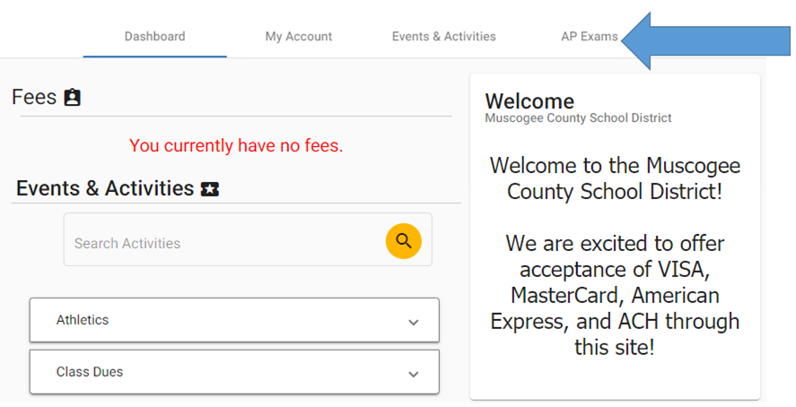

STEP 3: A list of all available AP exams will appear. If you are registering for an AP STEM exam, select that exam first, then click on all other AP exams you are registering for. You MUST select the AP STEM exam first in order to get the one free STEM exam funded by the state.
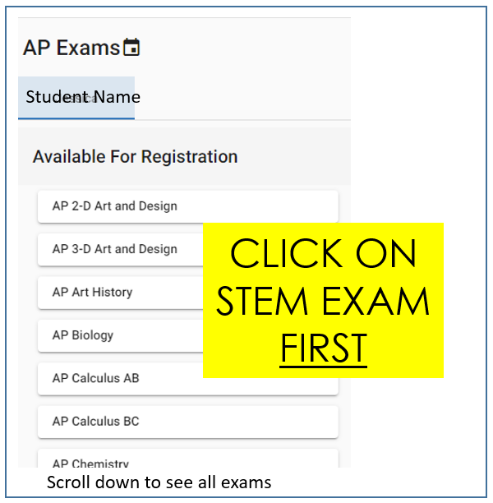
STEP 4: You must click the AP Information link and check the box acknowledging that you’ve read it. You must also check the box that lists the date & time of the AP exam. Then click REGISTER.
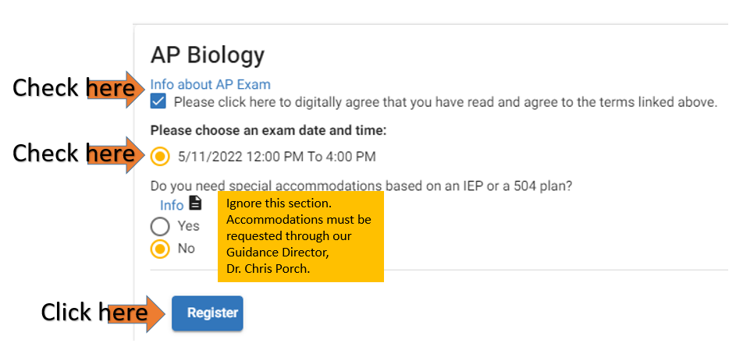

STEP 5: Select any additional exams you are registering for. Repeat the steps above.

STEP 6: After you have selected all of your exams you are registering for, click on CHECKOUT located at the top of the screen.
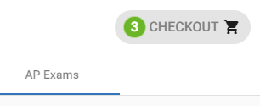

STEP 7: Look carefully at all the exams listed in your Shopping Cart and make sure you were charged correctly for your exam fees. Reminder: The state is paying for one free AP STEM exam for all students. If you are not registering for an AP STEM exam, you will not receive a free exam.
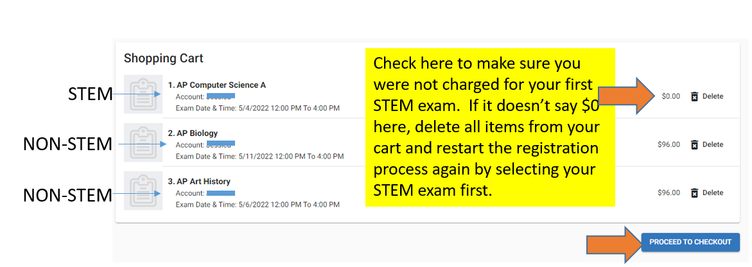

STEP 8: After verifying your charges are correct, click on PROCEED TO CHECKOUT.
My Payments Plus charges a fee to use their system.

FINAL STEP: Click PAY FOR ORDER.
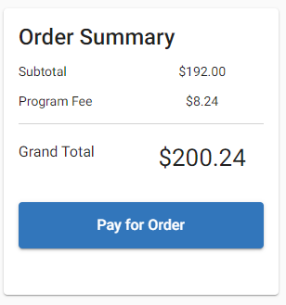
*Note: If you need to pay via cash, check or money order, you will need to see Ms. Allen in her office on 3rd floor - Room 303.

SPECIAL NOTE:
- STUDENTS WHO QUALIFY FOR A FEE REDUCTION will receive ONE FREE state funded exam at no charge (STEM OR NON-STEM). Each additional AP exam will cost $53. Check here to see if you qualify for a fee reduction. If you think you may qualify, you must submit your request for a fee reduction using this form. The deadline to apply is November 12, 2021. DO NOT MAKE YOUR PAYMENT ON MY PAYMENTS PLUS. See Ms. Allen in her office to make your payment. You must apply BEFORE making a payment. You will be notified via email if you are approved for a fee reduction. Then you may see Ms. Allen to pay with either cash, check, or money order. There is an additional fee for credit card payments. Do not make the payment online (regular price of exams will be charged if you do)--See Ms. Allen.
Again, to apply for a fee reduction use this form.

- The AP Exam Schedule and other important information can be found here.

