Summer Reading Assignment 2021:
Honors Ninth Grade Literature and Composition

STUDENT INSTRUCTIONS
- Students will read one (1) novel and analyze with the accompanying Major Works Data Sheet (MWDS) and Unit Review Questions.
- DUE DATE: You should download and save an electronic copy of your MWDS. Be prepared to submit your electronic MWDS/Unit Review Questions to Canvas during the first week of school. Your English teacher will give you instructions for this in class.
- You may be asked to complete assignments with your summer reading book, such as discussions, an in-class timed writing, (turning it into polished final draft), and/or a final project.
- You will be able to use ONLY your MWDS on the in-class writing, not the novel or any other notes. Be completely familiar with the plot, the characters, and the literary devices in your novel!
- LATE WORK POLICY: Any and all work that is not submitted by the due date and time will incur a 30% late penalty. If the late work is not submitted within 3 days of the original due date, the summer work will be recorded as a zero in the grade book.
- PLAGIARISM POLICY: Any student found guilty of plagiarism will receive a zero (0) for the assignment, will have their parents contacted, will be referred to the honor council, and will be stripped of any academic honors for a full calendar year. WARNING: Avoid copying another student’s work or copying and pasting from such sites like: Sparknotes, Enotes, and Bookrags, as this will warrant consequences for plagiarism.

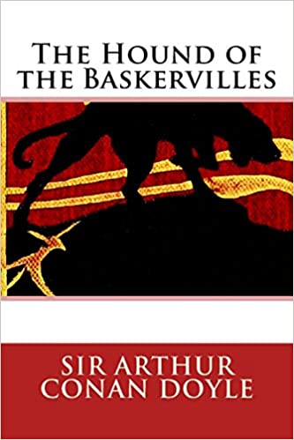
The Hound of the Baskervilles by Sir Arthur Conan Doyle
This novel is the third of the four crime novels written by the author featuring the detective Sherlock Holmes. Originally serialized in The Strand Magazine from August 1901 to April 1902, it is set largely on Dartmoor in Devon in England's West Country and tells the story of an attempted murder inspired by the legend of a fearsome, diabolical hound of supernatural origin. Sherlock Holmes and his assistant, Dr. Watson, investigate the case.

(***IF students read the previous title listed on the website and completed the worksheet, they are not required to read this title. Beginning of the year assignments can be modified to accommodate their work. Otherwise, the above novel is the current reading assignment for summer of 2021.)

Major Works Data Sheet

NAME: Period:
Title  Author  Date of Publication  Genre | Biographical information about the author
Historical information about the period of publication | Characteristics of the genre
Describe the author's style | An example that demonstrates the author's style
Memorable Quotes (Minimum of 3) | Significance of Quote
MWDS
List Characters (major and minor/protagonist or antagonist?) | Description of characters (words/phrases)
Setting | Why is the setting important to the novel?
Symbols (and meanings) | Significance of Opening Scene/Closing Scene
Possible Themes ---Topics of Discussion | Discuss the most important theme:
The Hound of the Baskervilles

1. What is Holmes’ attitude about the case before Watson leaves London? Does he believe in the spectral hound? What motive does he consider most likely for the murder of Sir Charles?

2. In what ways does the setting of Baskerville Hall on the moor contribute to the mood of the novel?

3. Using examples from the story, describe how Sherlock Holmes uses his scientific method to solve the mystery.

4. List and explain at least the 3 clues that foreshadow the identity of the murderer and the ending of the novel.

