CHS Summer Math Packet
All incoming freshmen are required to complete summer math assignments. To access these assignments, go to www.myopenmath.com and select register as a new student. Complete the New Student Signup information, entering the course ID and enrollment key as follows:
Course ID:104086
Enrollment key: toinfinity

Successful enrollment will bring you to the CHS Summer Math Course home page, as shown below. All instructions, resources, and assignments are provided in the online course, which will be available from May 24th at 6 AM until August 8th at 11:59 PM. All assignments are due on August 8th at 11:59 PM. No late assignments will be accepted after the online course closes.
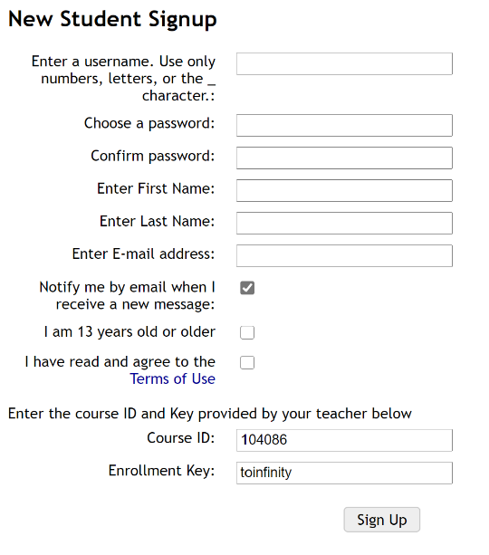
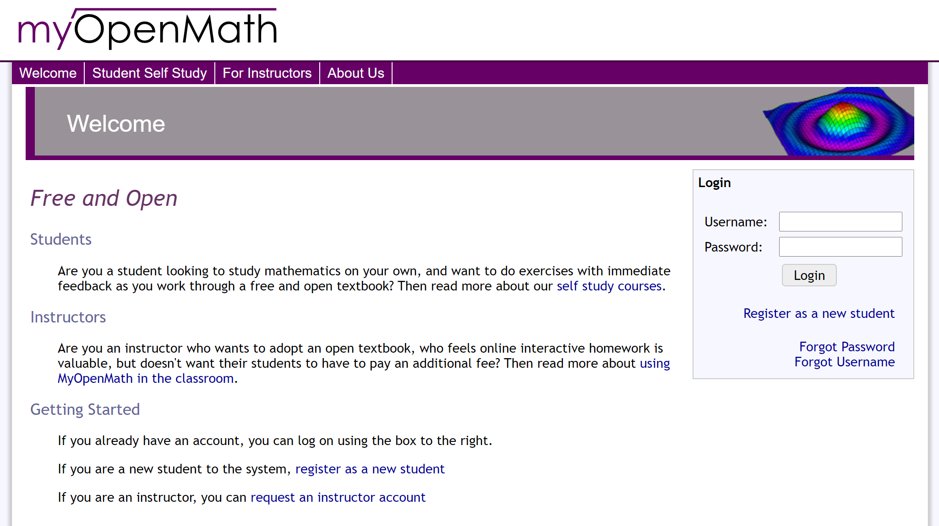

Course Homepage:
