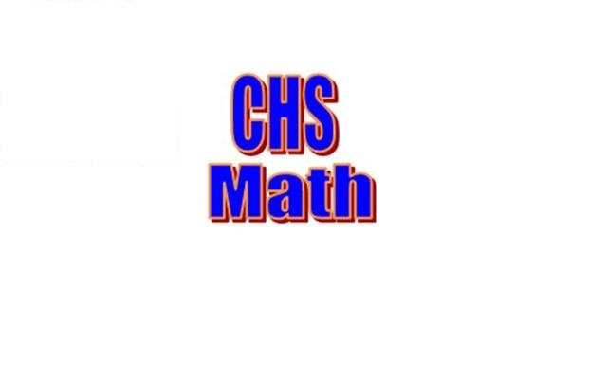

Dear Columbus High School Student,

The teachers in the Mathematics Department are looking forward to working with you again next year.

In preparation for a successful year in math, we suggest you review all previously learned GSE Algebra 1 or GSE Geometry standards. For reinforcement and remediation, ***all*** students may use the online math course materials to review, preview, or practice skills in preparation for next year. Students who did not attain a 75 or higher average in this year’s math course will be required to complete the online assignments for the course they took during the 2020-2021 school year.

To access the math review courses, go to [www.myopenmath.com](http://www.myopenmath.com) and select register as a new student. Complete the New Student Signup information, entering the required course ID and enrollment key as follows:

**Algebra 1 Review**

Course ID:109201

Enrollment key: algebraonereview

**Geometry Review**

Course ID:109204

Enrollment key: geometrysummerreview

Successful enrollment will bring you to the course home page. All instructions, resources, and assignments are provided in the online course, which will be available from May 14th at 6 AM until August 8th at 11:59 PM. If required, all assignments are due on August 8th at 11:59 PM. No late assignments will be accepted after the online course closes.

_____________________________________________________________________________________

Sincerely,



Storie L. Atkins

CHS Math Dept. Chair