Summer Reading Assignment 2021:
Honors Twelfth Grade Multi-Cultural Literature and Composition
From the titles listed below choose two to read as part of your summer reading assignment

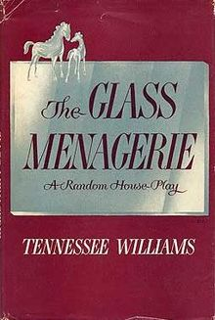 | 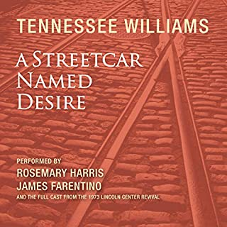 | 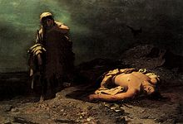 | 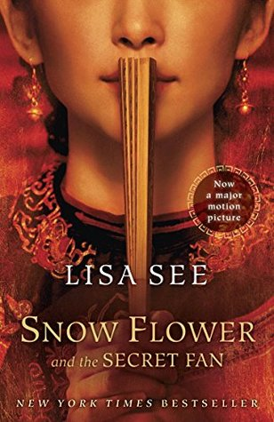
From her cramped St. Louis apartment, Amanda Wingfield dreams of her days as a Southern debutante while worrying about the future of her aimless son Tom and unmarried daughter Laura. With their father absent and the Great Depression in motion, the siblings find comfort in their foibles — alcohol, movies and writing for Tom and a collection of glass animals for Laura — which only heightens Amanda’s anxiety. When a gentleman caller arrives for dinner, the Wingfields are flooded with hope. But it’s unclear if his presence will change things for the better or shatter their fragile illusions. | The story famously recounts how the faded and promiscuous Blanche DuBois is pushed over the edge by her sexy and brutal brother-in-law, Stanley Kowalski. | Antigone  By: Sophocles  As the play begins, the invading army of Argos has been driven from Thebes, but in the course of the battle, two sons of Oedipus (Eteocles and Polynices) have died fighting for opposing sides. Their uncle, Creon, is now king of Thebes. He decrees that the body of Polynices, who fought against his native city, will not be given burial rites but will be left to rot, as a warning to traitors. Creon further decrees that anyone who does try to bury Polynices will be punished with death. | In nineteenth-century China, in a remote Hunan county, a girl named Lily, at the tender age of seven, is paired with a laotong, “old same,” in an emotional match that will last a lifetime. The laotong, Snow Flower, introduces herself by sending Lily a silk fan on which she’s painted a poem in nu shu, a unique language that Chinese women created in order to communicate in secret, away from the influence of men.
After completing the reading, complete the chart below.
Name of Work:_________________________________
Choose one Character that you can connect with or hate. | In 4 – 5 sentences explain why you hate or connect with the character. | Choose two passages that explains or shows how you connect or why you dislike the character. The passage might be an action, statement or description. | Explanation (What does the passage show or reveal) 4-6 sentences
 |  | (1)  (2) | (1)  (2)

Name of Work (2) :_________________________________
Choose one Character that you can connect with or hate. | In 4 – 5 sentences explain why you hate or connect with the character. | Choose two passages that explains or shows how you connect or why you dislike the character. The passage might be an action, statement or description. | Explanation (What does the passage show or reveal) 4-6 sentences
 |  | (1)  (2) | (1)  (2)

Please save a copy digital copy and have a hard copy on the first day of school.

