Summer Reading Assignment 2021:
Honors Ninth Grade Literature and Composition

STUDENT INSTRUCTIONS
- Students will read one (1) novel and analyze with the accompanying Major Works Data Sheet (MWDS) and Unit Review Questions.
- DUE DATE: You should download and save an electronic copy of your MWDS. Be prepared to submit your electronic MWDS/Unit Review Questions to Canvas during the first week of school. Your English teacher will give you instructions for this in class.
- You may be asked to complete assignments with your summer reading book, such as discussions, an in-class timed writing, (turning it into polished final draft), and/or a final project.
- You will be able to use ONLY your MWDS on the in-class writing, not the novel or any other notes. Be completely familiar with the plot, the characters, and the literary devices in your novel!
- LATE WORK POLICY: Any and all work that is not submitted by the due date and time will incur a 30% late penalty. If the late work is not submitted within 3 days of the original due date, the summer work will be recorded as a zero in the grade book.
- PLAGIARISM POLICY: Any student found guilty of plagiarism will receive a zero (0) for the assignment, will have their parents contacted, will be referred to the honor council, and will be stripped of any academic honors for a full calendar year. WARNING: Avoid copying another student’s work or copying and pasting from such sites like: Sparknotes, Enotes, and Bookrags, as this will warrant consequences for plagiarism.

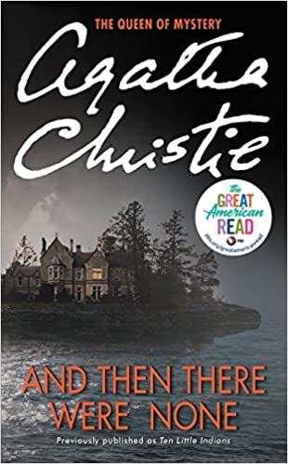
And Then There Were None by: Agatha Christie
1939. Europe teeters on the brink of war. Ten strangers are invited to Soldier Island, an isolated rock near the Devon coast. Cut off from the mainland, with their generous hosts Mr. and Mrs. U.N. Owen mysteriously absent, they are each accused of a terrible crime. When one of the party dies suddenly they realize they may be harboring a murderer among their number.
The tension escalates as the survivors realize the killer is not only among them but is preparing to strike again… and again...

Major Works Data Sheet

NAME: Period:
Title  Author  Date of Publication  Genre | Biographical information about the author
Historical information about the period of publication | Characteristics of the genre
Describe the author's style | An example that demonstrates the author's style
Memorable Quotes (Minimum of 3) | Significance of Quote
MWDS
List Characters (major and minor/protagonist or antagonist?) | Description of characters (words/phrases)
Setting | Why is the setting important to the novel?
Symbols (and meanings) | Significance of Opening Scene/Closing Scene
Possible Themes ---Topics of Discussion | Discuss the most important theme:
And Then There Were None Unit Review
- Complete the following chart. Don’t forget to include Isaac Morris
Character | Person whose death they are accused of | How they are responsible for that person’s death | How they, themselves, died (according to the poem)

- Define each of the following terms and connect to the novel using at least one example.
- Red Herring
- Pathetic Fallacy
- Foreshadowing

- State who the murderer is and provide the reasons for why the murderer killed the people they killed.

- Describe the role Isaac Morris played. Include how and why he die.

5. Describe why nobody from the mainland came to the rescue.

6. Did the authorities solve the murder mystery? In what way does the murderer confess his/her evil plan? Why choose this method?

7. List the three clues by which the murders might be solved as outlined in the confession letter.

8. Why did the murderer commit the crimes committed?

9. What is a “swan song” and what significance to the story does it have?

10. List the order in which the characters died. Why were they murdered in the order they were murdered? Do you agree with the order?

