AP Literature and Composition
Summer Reading Assignments
2021-2022

Ms. J. Williams & Mr. Ginn
Ginn.Charles.W@muscogee.k12.ga.us
Williams.Jacqueline.A@muscogee.k12.ga.us

AP Literature and Composition Students:
Advanced Placement (AP) Literature and Composition is designed to present an in-depth study of great literature from around the world. Through this course, you will hone your ability to read closely and think critically about texts from different genres, time periods, and canons. This is a college-level class with college-level requirements. In May, 2022, you will have the opportunity to earn college credit by taking the Advanced Placement examination in English Literature and Composition. Selection of this course indicates that you have already demonstrated a high achievement level in the analysis of literature, a superior writing ability, and a motivation to do college-level work in high school.
We are very excited about teaching AP Literature and Composition next year! As we have a great deal of work to do this up-coming year, your course will actually begin over the summer. The summer reading assignment is an important feature of the AP Literature and Composition course, and it serves two functions: 1) to keep you active as readers, and 2) to exercise your critical thinking muscles. This important requirement will ease your transition into your senior year.
Listed below are the required texts and directions for completing the summer reading assignment:

Required Reading
Everyone must read the following common text:
How to Read Literature like a Professor, Thomas C. Foster
Everyone must read one of the following novels below:
Exit West, Moshin Hamid
All the Light We Cannot See, Anthony Doer
The Poisonwood Bible, Barbara Kingsolver
Purple Hibiscus, Chimimanda Adichie
Home Going, Yaa Gysai
Extremely Loud and Incredibly Close, Jonathan Safran Foer
Pachinko, Min Jin Lee
In the Time of the Butterflies, Julia Alavarez
AP Lit. Summer Reading Menu
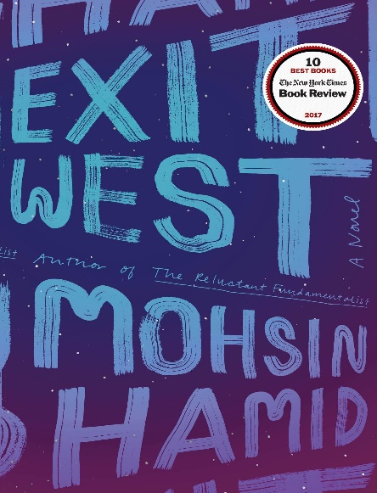
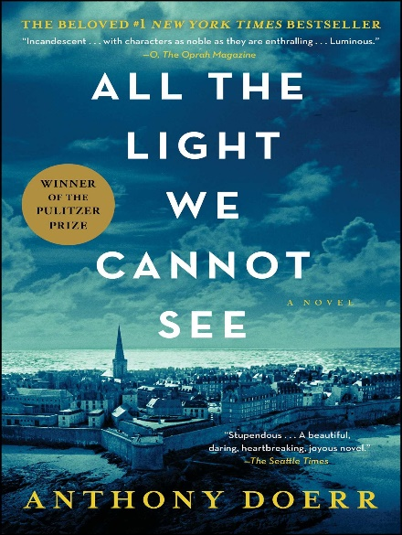

Description of Novel: Set in an unnamed locale with contemporary parallels to the Middle East, the story follows two young lovers as they flee their war-torn country through a series of magical portals. Through the deft use of magical realism, the novel explores the contemporary issues that surround the refugee crisis, including immigration, discrimination, and assimilation.
Description of Novel: This work of historical fiction is a tantalizing story of two characters whose paths will intersect in the waning days of World War II: an orphaned engineering prodigy recruited into the Nazi ranks, and a blind French girl who joins the Resistance. Tackling questions of survival, endurance and moral obligations during wartime, the book is as precise and artful and ingenious as the puzzle boxes the heroine’s locksmith father builds for her.

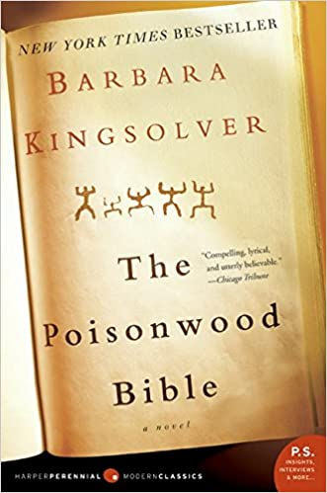
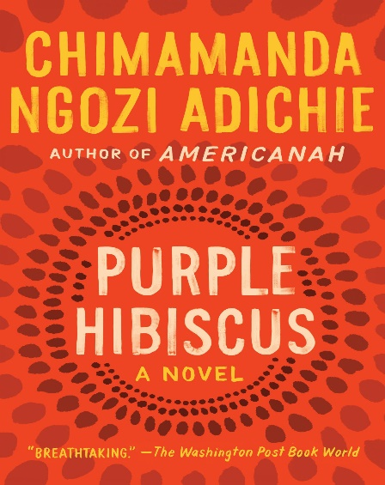

Description of Novel: : Set in postcolonial Nigeria, Purple Hibiscus is narrated by Kambili Achike, a 15-year-old who finds her voice as she begins to question first her father, then everything. Kambili’s dad, a rich scion, is a brave champion of free speech, but he’s also a meticulous, authoritarian patriarch. Kambili’s understated tone cushions the blows of the violence she describes both inside and outside her home. Chimamanda Ngozi Adichie’s first novel is lush with telling detail about her native country, homing in on the contrasts between rich and poor, young and old, and delivering sharp truths about power and freedom.
Description of Novel: The Poisonwood Bible is a story told by the wife and four daughters of Nathan Price, a fierce, evangelical Baptist who takes his family and mission to the Belgian Congo in 1959. They carry with them everything they believe they will need from home, but soon find that all of it—from garden seeds to Scripture—is calamitously transformed on African soil. What follows is a suspenseful epic of one family’s tragic undoing and remarkable reconstruction over the course of three decades in postcolonial Africa.

AP Lit. Summer Reading Menu (Continued)
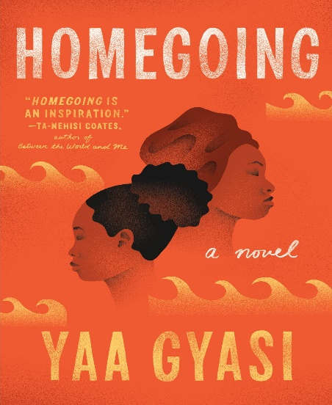
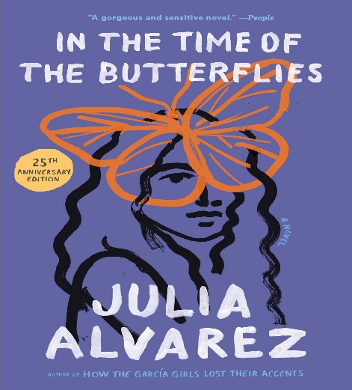
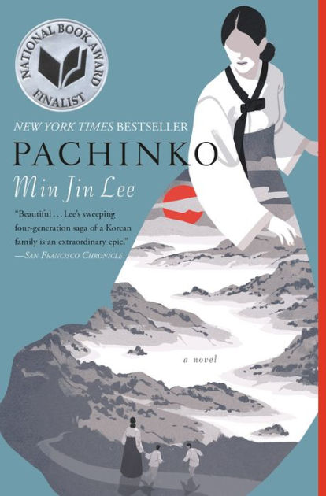
Description of Novel: in this novel of historical fiction, the voices of all four sisters--Minerva, Patria, María Teresa, and the survivor, Dedé--speak across the decades to tell their own stories, from secret crushes to gunrunning, and to describe the everyday horrors of life under Trujillo’s rule in the Dominican Republic. Through the art and magic of Julia Alvarez’s imagination, the martyred Butterflies live again in this novel of courage and love, and the human costs of political oppression.
Description of Novel: This novel is a work of epic historical fiction following a Korean family who eventually immigrates to Japan. The character-driven tale features a large ensemble of characters who become subjected to issues of racism and stereotypes, among other events with historical origins, as they seek to control their destiny in another land.
Description of Novel: Nine-year-old Oskar Schell has embarked on an urgent, secret mission that will take him through the five boroughs of New York. His goal is to find the lock that matches a mysterious key that belonged to his father, who died in the World Trade Center on the morning of September 11. This seemingly impossible task will bring Oskar into contact with survivors of all sorts on an exhilarating, affecting, often hilarious, and ultimately healing journey.
Description of Novel: Homegoing follows the parallel paths of these sisters and their descendants through eight generations: from the Gold Coast to the plantations of Mississippi, from the American Civil War to Jazz Age Harlem. Yaa Gyasi’s extraordinary novel illuminates slavery’s troubled legacy both for those who were taken and those who stayed—and shows how the memory of captivity has been inscribed on the soul of our nation.

How to Read Literature Like a Professor Application Assignment:
Thomas Foster’s How to Read Literature Like a Professor (HTRLLAP) is an excellent primer on how to plumb the depths of literary meaning beyond surface-level narrative concerns. Indeed, Thomas’s text urges you to turn away from performing distant readings of literary works by giving you the tools needed to perform nuanced, close reading of literary texts. Over the course of his work, you will proceed through twenty-seven chapters that present different case studies on how to attend to larger figurative, archetypal, symbolic, and socio-political implications of a text, ones that will provide you with interpretative frameworks for approaching future works of literary fiction.
Directions:
In order to complete the HTRLLAP application assignment, you must first read both HTRLLAP and one of the novels of your choice above. The novel that you pick is totally up to you; pick one that speaks to you! Then, you must apply three different HTRLLAP chapter concepts to your chosen novel by completing three total application papers. In each application paper, you will isolate a specific moment in the novel, apply a chapter from HTRLLAP to that moment, and suggest how the concept presented in HTRLLAP can help us better understand that moment. In order to get full credit, each application paper must summarize a moment from the novel using textual evidence, explain a concept from HTRLLAP using textual evidence, and suggest how HTRLLAP can help us unpack the “deeper meaning” in the moment from the novel. Each application response paper should be 300-500 words, double-spaced, and written in accordance with MLA documentation style. In these application papers, your voice should be formal, academic, and polished.

HTRLLAP Application Paper Requirements
Genre of Writing | Length | Style
3 Textual Evidence-Based Application Papers | 300-500 Words Each (1 to 1½ Double-Spaced Pages) | MLA

HTRLLAP Application Paper Components
- Introduce a moment or scene from your novel.
  - When summarizing this scene, you must describe it specifically by grounding it in textual evidence.
    - At least one quote is required.
- Introduce a relevant chapter from HTRLLAP.
  - When summarizing this chapter, you also must describe it in detail by grounding it in textual evidence.
    - At least one quote is required.
- Suggest how the concept from HTRLLAP can help to better unpack the figurative, archetypal, symbolic, or socio-political value in the moment/scene.
- While you do not need any quotes in this section of your paper, this commentary is the most important part of the paper and should be multiple sentences long.

HTRLLAP Application Paper Rubric (75pts. Total)

Application Essay 1 | Application Essay 2 | Application Essay 3 | HTRLLAP Application Paper Rubric
/5 | / 5 | /5 | Introduce a moment or scene from your novel.  - When summarizing this scene you must describe it specifically by grounding it in textual evidence.  - At least one quote is required.
/5 | /5 | /5 | Introduce a relevant chapter from HTRLLAP.  - When summarizing this chapter you also must describe it in detail by grounding it in textual evidence.  - At least one quote is required.
/10 | /10 | /10 | Suggest how the concept from HTRLLAP can help to better unpack the figurative, archetypal, symbolic, or socio-political value in the moment/scene.  - While you do not need any quotes in this section of your paper, this commentary should be multiple sentences long.
/2 | /2 | /2 | Lists Author’s Name and Title of Work
/3 | /3 | /3 | Adheres to MLA Formatting Conventions
-10 Points (Per Day Late) |  |  | Turned-In On Time
-10 Points |  |  | Word Count Met  ***If the essay is severely underdeveloped (250 words or less), the teacher reserves the right to require an automatic revision, and the essay will only be eligible for the minimum passing score: Example- 53/75.***
Automatic Revision & Consequence Determined by Honor Council |  |  | Passes Plagiarism Check  ***If you don’t pass the turn-it-in.com plagiarism check, it is an automatic referral to honor council.**

Requirements for the First Day of AP Literature and Composition
- Bring a Digital Version of the AP Literature and Composition Summer Reading Assignment to Class for Submission.
  - The assignment needs to be a final draft that meets all of the rubric requirements.
  - The assignment will be ready to submit on day one, and it must pass a plagiarism check.

- Bring Copy of HTRLLAP & Your Summer Reading Novel of Choice (Hard or Digital Copy)
  - During the opening weeks of our class, we will be reviewing HTRLLAP and using our respective novels as vehicles through which to illustrate the chapter concepts.

- Be Prepared to Discuss Both HTRLLAP & Your Novel of Choice.
  - Activities during the first week will include small and large group discussions, presentations, and perhaps projects.
  - A deep familiarity with both texts will set you for success in the opening weeks of our course.

