Community Service

“To whom much is given, much is required.” By being involved in community service, students are introduced to the various needs, resources, and opportunities within our community. In addition, community involvement opens up possibilities for career interests and helps build a résumé for summer work, scholarships, and awards applications.

Expectations for Students

9th, 10th, and 11th grade: Students must register online for a term and an agency using the Community Service Booklet provided at school. Due to school closures for the remainder of 2020, all incoming freshmen, sophomores, and juniors will register in August. Failure to register online, changing agencies, or changing terms results in Detention Saturday School. Freshmen, sophomores, and juniors are expected to complete 20 hours of service per year with one specific non-profit organization. Students submit their community service log and evaluation form to their homeroom teacher on the designated due dates for each term.

12th grade: Seniors are not required to complete community service as they will obtain hours through their Senior Project or AP Research Project.

NOTE: If a student fails to complete their community service or receives a poor evaluation, it may constitute further disciplinary consequences or potential dismissal from our program.

2020-2021 Community Service Registration
Student Instructions

- Whether you plan to complete your community service hours in the fall or spring, sign up online. All current students enrolled in Columbus High School for the 2020-21 school year need to sign up for community service.
- Summer community service is cancelled. This means that NO student will be allowed to complete community service over the summer. Any student who has previously submitted an approved summer proposal is now null and void. Due to the uncertainty of when service agencies may reopen or when public health officials will deem it safe for groups to resume meeting and social distancing practices to be lifted, this is the best option to ensure student and community safety. Please note: All 9th, 10th, & 11th grade students will register online for community service when we can safely return to school. There will be opportunities for students to serve for fall or spring term.

- Students will receive a community service booklet once school begins in August. Note that some agencies have a minimum age limits: Columbus Museum, East Alabama Humane Society, Easter Seals, Habitat for Humanity, House of Heroes, Liberty Theatre, and Springer Opera House.
- Discuss your choice with your parents. They must be able to provide transportation for you if necessary. Your parents must sign the confirmation form, indicating that they approve your choice. Do not sign your parent’s name. If they call and say you cannot do your work because of transportation problems, the confirmation form will be shown to them indicating they approved of your agency and the transportation it would require!
- You may begin to register online in the computer lab, media center, or at home between 4:00 PM Monday, August, 17th, 2020 and 8:00 AM Friday, August 21, 2020.
- Select carefully. YOU CANNOT CHANGE YOUR COMMUNITY SERVICE (AGENCY OR TERM) WITHOUT APPROVAL FROM MRS. BOSWELL. CHANGING YOUR AGENCY OR TERM WILL RESULT IN DETENTION SATURDAY SCHOOL.
- COMMUNITY SERVICE REGISTRATION PROCEDURES (ALSO IN YOUR CS BOOKLET):
- To register, go to any browser and type: http://apps.muscogee.k12.ga.us/SignMeUp
- If you are logged on to a school device you will automatically be taken to the registration page once you click on the log-in button on the top right. If you are not using a school device, when you click on the log-in button you will need to enter your GTID number and password.
- If you have trouble you might try a different browser such as Chrome or Firefox. Safari on iphones may not work.
  - Click the word “Events” (top right) or the “GO TO EVENT LIST” button.
  - You will be taken to the “Available Events” page.
  - Find the event (agency) where you want to volunteer, read the description carefully and click “Sign Me Up!”
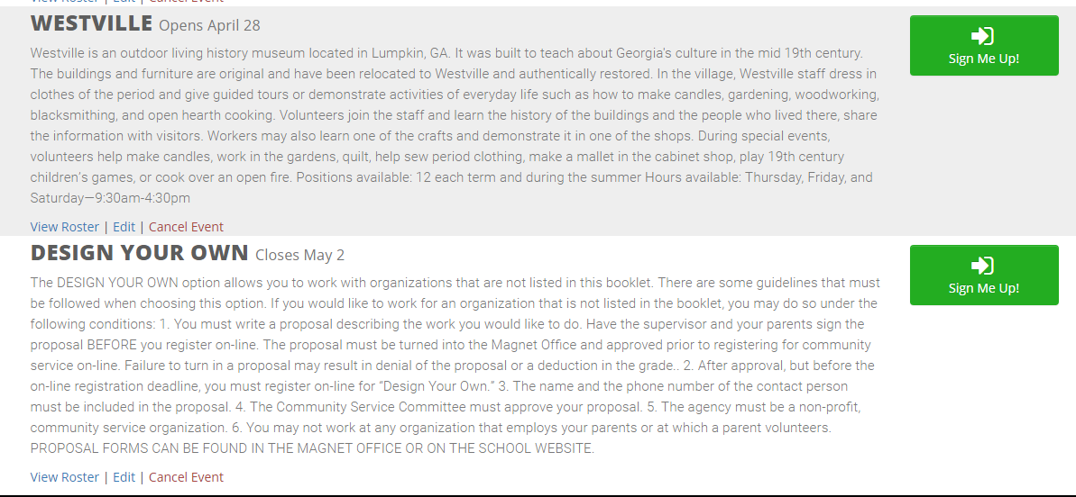
  - At the bottom of the page you will have the option of selecting a term if one is still available.
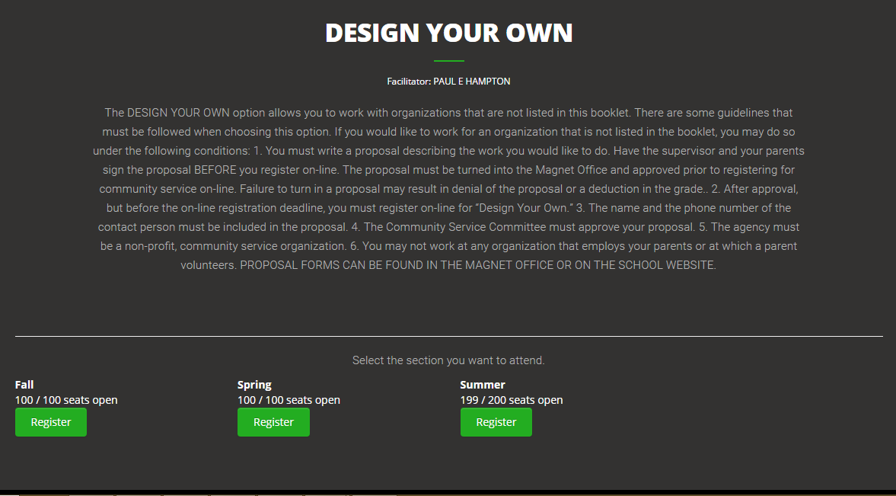

- You will see the following confirmation and directions to “Print Permission Form.”
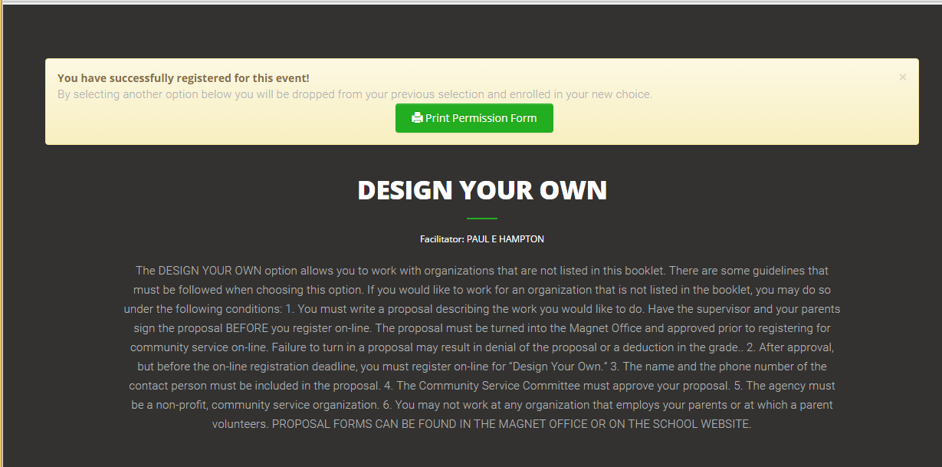

PRINT THE CONFIRMATION PAGE AND HAVE IT SIGNED BY A PARENT.
- Return your confirmation form to your homeroom teacher by Friday, August 21st. Failure to turn in the confirmation form on time will result in detention. Failure to sign up or failure to complete community service hours on schedule will result in detention Saturday school, administrative disciplinary action, or potential dismissal from Columbus High School.
- NOTE: Any and all DESIGN YOUR OWN community service proposals MUST BE PRE-APPROVED by Mrs. Boswell before you can sign up online. Get your proposal online at: http://www.columbushighga.org/?page_id=7160 OR stop by the magnet office, so you can meet your deadline.
- There will be an agency orientation led by your agency facilitator when school resumes in August. Check the daily announcements slide show and the trifold board in front of the auditorium for orientation times. Go to your FACILITATOR or the MAGNET OFFICE if you have questions.
- This is your job. If you have any problems, YOU should handle it. Your parent SHOULD NOT CALL FOR YOU. Steps for handling problems:
- Go talk to your facilitator.
- Go talk to Mrs. Boswell in the Magnet Office.
- Do not have your parent call the agency. Your parents may call me if you have a major problem that requires their intervention.

- Note that the Community Service Booklet has the due dates for completion of your community service hours.
  - SUMMER TERM CANCELLED
- Fall: Monday, December 7th, 2020
- Spring: Monday, April 26th, 2021

