AP US HISTORY
Summer Assignment

Read the novel The Jungle by Upton Sinclair.

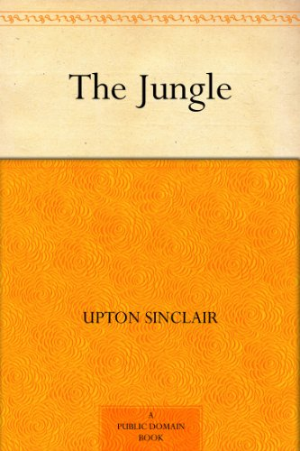
Test will be given upon return to school.

