Advanced Placement English Language & Composition
Summer Reading assignment
Columbus High school
liberal arts college preparatory magnet
2020-2021 school year

AP LANGUAGE & COMPOSITION SUMMER READING LIST:
The purpose of summer reading in AP English Language and Composition is to prepare you for the level of reading, writing, and thinking that is the hallmark of this course. The following selections are included on the approved AP Central College Board list for suggested readings for this course.
Please note the following message from College Board: “CONTROVERSIAL TEXTUAL CONTENT issues that might, from particular social, historical, or cultural viewpoints, be considered controversial, including references to ethnicities, nationalities, religions, races, dialects, gender, or class, may be addressed in texts that are appropriate for the AP English Language and Composition course. Fair representation of issues and peoples may occasionally include controversial material. Since AP students have chosen a program that directly involves them in college level work, participation in this course depends on a level of maturity consistent with the age of high school students who have engaged in thoughtful analyses of a variety of texts. The best response to controversial language or ideas in a text might well be a question about the larger meaning, purpose, or overall effect of the language or idea in context. AP students should have the maturity, skill, and will to seek the larger meaning of a text or issue through thoughtful research” (AP.CollegeBoard.org).
An overview of your reading and writing assignments are as follows:
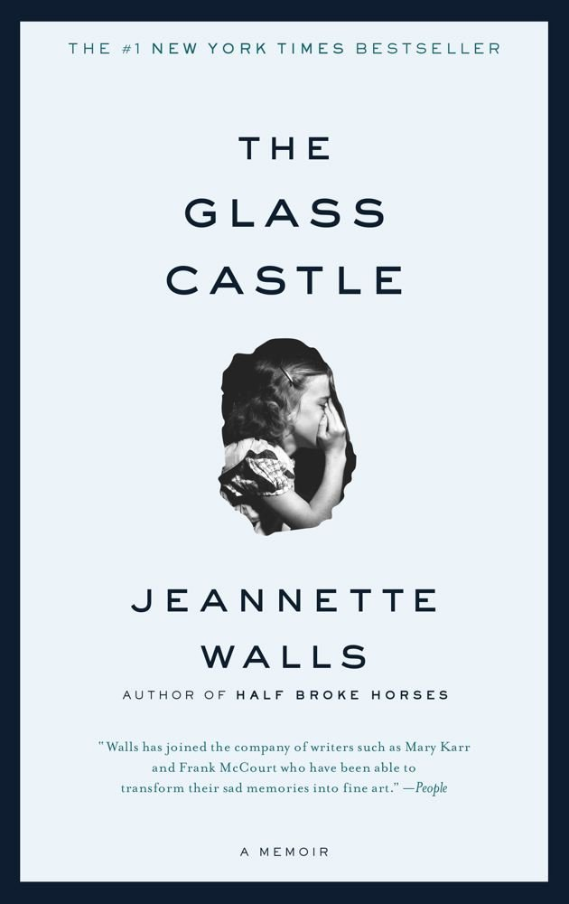
JUNE 2020
* The Glass Castle by Jeannette Walls
For this memoir, complete the reading and writing assignment by June 30, 2020. Make sure you annotate (write notes, questions, highlight, etc.) as you read. WRITE in your book, or write separate chapter notes as you read. This will assist with your overall comprehension of the book. You will have a 50-point writing assignment to complete by June 30 and a 100-point test on this non-fiction book within the first two weeks of school. Your writing assignment must be typed and printed and will be due the first day of school – Monday, Aug. 10, 2020 to your AP Lang teacher. Any work not submitted on the due date will incur a 50% penalty and will not be accepted after Tuesday, Aug. 11, 2020. Furthermore, you will need to save your typed essay on a thumb drive or in a Word or Google document as it will need to be uploaded to the turnitin.com database during the first week of school. Your essay assignment will not be graded until it is submitted to the turnitin.com database to check for plagiarism; thus, if you have not saved your document, you will receive a 0 for this assignment.

Parents & Students: Please feel free to contact Shannon Williamson or Lisa Mills via email at Williamson.Shannon.r2@muscogee.k12.ga.us / Mills.Lisa.K@muscogee.k12.ga.us
with any questions or concerns you may have.

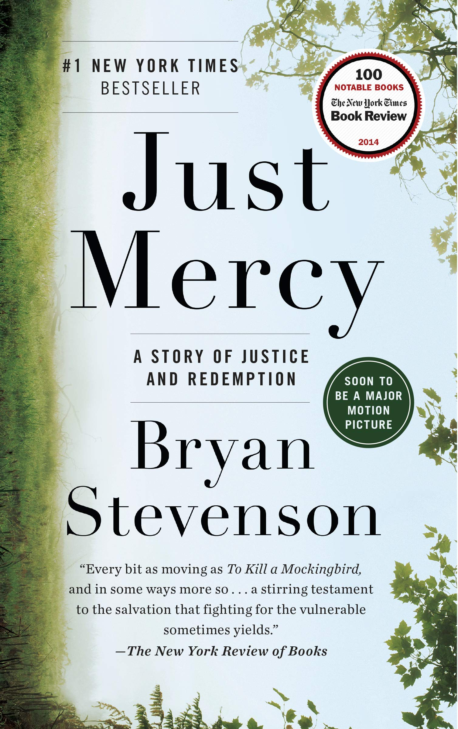
JULY 2020

* Just Mercy: A Story of Justice and Redemption by Bryan Stevenson
(Do not read the young adult version).

For this memoir, complete the reading and writing assignment by July 31, 2020. Make sure you annotate (write notes, questions, highlight, etc.) as you read. WRITE in your book, or write separate chapter notes as you read. This will assist with your overall comprehension of the book. You will have a 50-point writing assignment to complete by July 31 and a 100- point test on this non-fiction book within the first two weeks of school. Your writing assignment must be typed and printed and will be due the first day
of school – Monday, Aug. 10, 2020 to your AP Lang teacher. Any work not submitted on the due date
will incur a 50% penalty and will not be accepted after Tuesday, Aug. 11, 2020. Furthermore, you will need to save your journal assignment on a thumb drive or in a Word or Google document as it will
need to be uploaded to the turnitin.com database during the first week of school. Your journal assignment will not be graded until it is submitted to the turnitin.com database to check for
plagiarism; thus, if you have not saved your document, you will receive a 0 for this assignment.

Parents & Students: Please feel free to contact Lisa Mills or Shannon Williamson via email at
Mills.Lisa.K@muscogee.k12.ga.us/Williamson.Shannon.r2@muscogee.k12.ga.us
with any questions or concerns you may have.

AUGUST 2020

- Rhetorical Terms - Definitions and Examples. This is individual work, and you must complete your own work! Any work submitted which looks alike or too closely similar will be investigated for possible plagiarism/cheating. You will make flashcards defining the rhetorical terms (listed on the last page of this document). You should also learn these terms as you will be applying them during annotations. If you have difficulty understanding a term, there are many resources online to assist you with understanding. You will submit your flashcards to your AP English Language teacher on the FIRST day of class, Monday, August 10, 2020. If work is not submitted on the due date, it may be submitted on the following day for a deduction of 50%. No work will be accepted after the 2nd day. You will be tested over these terms within the first three weeks of school, so you should spend time studying and learning them in August!
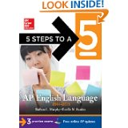

5 Steps to a 5 for AP English Language and Composition* by Barbara Murphy and Estelle Rankin.

*You will need to purchase the most current edition, since the AP Exam for AP English Language & Composition was revised in 2019. Purchasing this book is required, and it will assist you in exam preparation.

AP LANGUAGE & COMPOSITION SUMMER WRITING ASSIGNMENT INSTRUCTIONS:
You will complete writing assignments for Jeannette Walls’ The Glass Castle and Bryan Stevenson’s Just Mercy: A Story of Justice and Redemption. Both of your assignments (June-Glass Castle; July- Just Mercy) must be typed, printed, saved, and ready to submit the first day of school. Make sure you save an electronic copy of all of your summer work (on a portable flash drive, Google docs, Word, etc.) as we will upload your essays and journals to the Turnitin.com plagiarism database during the first two weeks of school.

ABOUT PLAGIARISM:
Please keep in mind that all of your assignments should be YOUR original work and your work ALONE. Do NOT be tempted to share answers with another student or plagiarize from the internet because it will be easily detected. Should any student(s) be found guilty of plagiarizing or copying another student’s work, he or she will receive a zero on the summer reading assignment, will have his or her parents contacted, will receive permanent documentation on his or her school transcript, will be stripped of any academic honors for a full school year, and will appear before the CHS Honor Council for further disciplinary action. As our school motto reads, “Commitment, Honor, and Success,” we expect your work to mirror our desire for your personal success and academic excellence.

JUNE WRITING ASSIGNMENT
JEANNETTE WALLS’ THE GLASS CASTLE
DUE: JUNE 30, 2020 SUBMIT IN CLASS: AUG. 10, 2020

You have a significant amount of summer work, so strive to complete the novel and your essay by the above date although the essay will not be submitted until the first day of school
Monday, August 10, 2020. On the first day of school, you must submit a printed copy of your
essay to your AP Lang teacher. Again, save your essay carefully as we will be uploading it to the
Turnitin.com website during the first week of school. NO essay will be graded until it has been checked for plagiarism in the Turnitin.com website.

GRADING: Please be aware should you be found guilty of plagiarism (either copying or allowing someone to copy your work), you will receive a zero. Grade penalties will be calculated based on your overall % of matching to other sources submitted to the database as well as other online documents. THE ESSAY YOU WRITE SHOULD NOT EXCEED 20% WITHIN THE TURNITIN.COM DATABASE! Essentially, 80% of your essay should be your own words with minimal quotes contained. Commonality in excess of 20% will receive grade deductions and potentially a zero on the assignment. Please keep in mind you will also lose points should you submit your work late.Turnitin.com holds all previous submissions, so do not be tempted to copy an upperclassmen’s work! Reminder, you MUST save all of your work to be submitted to the Turnitin.com database during the first week of school. Any work not submitted to the Turnitin.com database will not be graded and will thus receive a grade of zero!

I. Assertion Short Write Response/The Glass Castle essay requirement: 50 points

Select ONE of the prompts from below, and argue whether you agree (defend), disagree (challenge), or qualify (agree in some aspects but disagree in others). You must use concrete examples from the novel as evidence to prove your opinion. Your answer must include at least 2-3 examples from The Glass Castle (quotes or summary of particular details from the story in MLA format). You may also use your personal experiences, and/or what you have learned previously (through reading or historical examples) as evidence. A high scoring response will contain multiple examples to prove your opinion. Your response should be at least 500-700 words and include a word count.

Your response should contain an inviting introduction with a clear thesis, supporting body paragraphs, and a satisfying conclusion. Keep in mind to include examples from the text, from your personal experience, and/or examples from other books you have read, or examples from history. As you compose your response, please consider the following:
- For this assignment, you must provide evidence from The Glass Castle. Make sure you cite the page numbers (in MLA format) when you cite from the book. See the essay example below
- Provide specific evidence from personal observation, experience, and/or reading to support your position.
- Note its complexity (nuances) and forge connections between your position and that of the writer. Resist the immature temptation of oversimplification!
- Provide a conclusion that does not merely summarize, but rather addresses the “so what?” issue: How should educated, informed citizens continue to think about the issue at hand? How will it continue to influence readers’ lives?
- Save your essays carefully, and print a copy to submit on the first day of school to your AP English Language teacher (see above). Your essay should be single-spaced even though MLA is usually double-spaced, typed in Times New Roman 12- point font with one-inch margins, and be one page if possible. Make certain your MLA heading is in the left upper portion of your essay ½ inch from the top of the page, and indented 1 inch from the left margin. The (title) quote and author should be centered and typed at the top of the page, and your heading and (title) words in the quote do NOT comprise part of the 500+ word response.

II. PROMPTS: Select only ONE quote from the choices below:

“Parents can only give good advice or put them on the right paths, but the final forming of a person's character lies in their own hands.” -Anne Frank

“Children have never been very good at listening to their elders, but they have never failed to imitate them.”
-James Baldwin

“We could never learn to be brave and patient if there were only joy in the world.” -Helen Keller

“People are just as happy as they make up their minds to be.” -Abraham Lincoln

“Money has never made man happy, nor will it, there is nothing in its nature to produce happiness. The more of it one has the more one wants.” -Ben Franklin

“Success is to be measured not so much by the position that one has reached in life as by the obstacles which he has overcome.” -Booker T. Washington

III. GRADING: Your typed response should be at least 500 words and single- spaced. Each response will be evaluated according to the following criteria:
1. Did you fully explain the author’s position (the quote)?
2. Did you make clear in the introduction your position on the quote (thesis statement -defend, challenge, or qualify)? Did you make sure to note the complexities of the argument without oversimplifying?
3. Did your body paragraphs list specific reasoning for why you agree, disagree, or qualify, giving textual evidence in MLA format to support your reasoning?
4. Did your conclusion do more than merely summarize, but instead offer final thoughts on a complex issue?
5. Did you check for grammatical correctness, italicize the title of the novel, and use correct MLA format in documenting quotes within your essay? (See sample below for guidance).

IV. SAMPLE STUDENT RESPONSE:
Joe Miller
AP Language (This is your heading)
30 June 2020

“Parents can only give good advice or put them on the right paths, but the final forming of a person's character lies in their own hands.”
- Anne Frank (Title centered)

Many spend a lifetime defining themselves as individuals; a lifelong journey that begins in adolescence and transcends into adulthood. This journey, however, is not without the aid of others. Parents and friends have enough potential to influence someone’s life as is allowed to them. It is the individual who then decides what will affect them in life. Like Frank, teenagers are most aware of this transition; following past traditions to be responsible for their lives.
Despite a reputation for defiance, the years spent arguing as a teenager are seemingly necessary to develop one’s future. As social creatures, many people’s attention is set on how they may be viewed by others rather than by themselves. Teens are just beginning to create an identity for themselves, one reflecting what they believe, rather than the beliefs of the family.
In Jeanette Walls’ memoir, The Glass Castle, she begins struggling with her parents’ way of life once she acknowledges it is not one she wants for herself. A defining moment in this transition is when Walls compares her mother’s writing aspirations to professional journalists and concludes, “I decided I wanted to be one of the people who knew what was going on” (204). Not only does she spotlight qualities she wants to aspire to, but also notes negative traits of her mother that she does not want for herself. Echoing Frank’s observation that after years of absorbing qualities and beliefs from parents, it is then the duty of the teen to evaluate what remains important to them and apply it to their life.
Dating back to Ancient Greece, varying religious and cultural ceremonies have been known to celebrate the first steps into the adult world. In places like Sparta, young males were usually given a mentor that would guide them and give them the skills needed to be successful as an adult. In the Baha’i faith, when a child reaches the appropriate age, it is the obligation of the child to decide whether or not they wish to remain in the faith. This is similar to some Christian baptismal rituals in which they are baptized once as a child and then again at a later age, if they choose to reaffirm their beliefs. Walls’ mother also placed all religious responsibilities on her children saying, “It was up to every human being to find his or her own way into heaven” (207). In the face of being raised with certain beliefs and practices, in many religions and cultures, it is the choice of the individual for what they wish to dedicate their life.
By the latter end of the transition into adulthood, young people are expected to be able to make the right decisions without the constant support from parental figures as was usual before. Despite having a seemingly constant faith in her parent’s schemes, Walls takes a stand, like so many others, and distances herself from the childhood fantasies fed to her. She rejects what she was taught and makes the decision that her own life would not be centered on the Glass Castle as she tells her father, “Go ahead and build the Glass Castle, but don’t do it for me” (238). However, just because teens are now responsible for their own lives, it does not mean they will make the right choices, but from that transitional point on, the young adult is accountable for the decisions that shape his or her own character; whether it be for good or bad.
Life is difficult. It is no easier for one person than it is the other. Although the tribulations vary, they remain constant in everyone’s lives. At some point, however, each person has to take responsibility for his or her own life; defining their character according to their personal views. Their values will fail them, and they will make mistakes, but they will learn. To go through life dependent and without the possibility of making mistakes, is to go through life without living.
Include a word count on the bottom right! (654 words)

JULY WRITING ASSIGNMENT
BRYAN STEVENSON’S – JUST MERCY: A STORY OF JUSTICE AND REDEMPTION DUE: JULY 31, 2020 SUBMIT IN CLASS: AUG. 10, 2020.

GRADING: Please be aware should you be found guilty of plagiarism (either copying or allowing someone to copy your work), you will receive a zero on this assignment. This assignment will be worth 50 points and will be submitted to the Turnitin.com website to check for plagiarism during the first week of school. Do your own individual work, and be proud of it!

A # 1 New York Times Bestseller, “Just Mercy is at once an unforgettable account of an idealistic, gifted young lawyer’s coming of age, a moving window into the lives of those he has defended, and an inspiring argument for compassion in the pursuit of true justice” (www.bn.com).

Your task is to read the novel, and complete the following critical reading and writing activities:
1. As you read, you will write a dialectical journal in which you pick 10 significant passages from the book. These passages should demonstrate your engagement with the novel; thus, they should be chosen from at least 10 different chapters of the book. You may give your personal reaction to the selected passage, discuss ideas or actions of the author or character(s), make connections, write what the passage makes you think or feel, analyze the passage and its relationship to the story as a whole, or analyze the text for the use of rhetorical devices (imagery, structure, style, tone, rhetorical appeals such as ethos, pathos, logos, diction, etc.) The purpose of the dialectical journal is to help you develop a better understanding of the text as you read. Your responses should be at least 3-6 sentences in length (required 50 words or more).
2. Prepare your dialectical journal (via a Word document) that includes the quote from the novel written in MLA format (with page number) as well as your written response in the third column.
4. Prepare your entries in a three-column format as the following model illustrates. You may NOT use the following example as one of your ten required entries. Please include your name & assignment title – Just Mercy – Dialectical Journal

Please see the sample dialectical journal on the following page:

Your name:
Just Mercy Dialectical Journal
 | Quote/Passage from the novel: | Analysis & Significance:
1 | “During the talk, I noticed an older black man in a wheelchair who had come in just before the program started. He was in his seventies and was wearing an old brown suit. His gray hair was cut short with unruly tufts here and there. He looked at me intensely throughout my presentation but showed no emotion or reaction during most of the talk. His focused stare was unnerving. A young boy who was about twelve had wheeled him into the church…” (Stevenson 45). | In this passage the author’s use of imagery and details vividly captures the older gentleman in the audience. Through his descriptions, it is easy to visualize the elderly gentleman and feel the author’s apprehension as he delivers his talk. Later in the chapter when we discover even more details about this man, it seems to be a turning point in the novel for Stevenson as he realizes the need to open an office in Alabama as well as the need to continue fighting even harder for justice and reform.  (89 words)
 | - MLA format required ! | - Word count required!

GRADING FOR JULY WRITING ASSIGNMENT (50 points—5 points per entry)
In order to receive full credit, you must meet the following criteria for each entry:
1. Did you follow the correct MLA format for the quote or passage and the three-column format as shown above?
2. Did you give appropriate explanation of your reasoning for the significance of the quote with at least 3-6 sentences and at least 50 words (with word count) per entry?
3. Again, make certain you save this journal on thumb drive or in a document to later be submitted to Turnitin.com. Submit a printed copy to your teacher on the first day of school, August 10, 2020. If your journal is not submitted on Aug. 10, 2020, you will incur a 50% deduction on your grade, and the assignment will not be accepted after Aug. 11, 2020.

AUGUST ASSIGNMENT – UNDERSTANDING RHETORICAL TERMS
SUBMIT IN CLASS: AUGUST 10, 2020

Purpose: Knowing the following rhetorical terms will allow you to better discuss an author’s work at a more sophisticated level as you recognize the rhetorical devices an author uses to achieve his or her purpose. Throughout this course you will learn approximately 100 rhetorical terms; learning the following rhetorical terms this summer will aid you in this process.

Directions:
Rhetorical Terms Flashcards-Due the first day of school, August 10, 2020.
Define the following terms using the Internet, and you may copy definitions, or write them in your own words.

Familiarize yourself with the following terms by creating flashcards using 3x5 or 4x6 index cards. Write the term on one side, the definition, and an example on the other side of the card. If you have difficulty defining or understanding a term, there are many resources online to assist you. Place a title flashcard with your first and last name and all 30 flashcards within a rubber band, and submit your flashcards to your AP English Language teacher on the first day of class, August 10, 2020. If your work is not submitted on the due date, it may be submitted on the following day for a deduction of 50%. No work will be accepted after Aug. 11, 2020. You will be tested over these terms within the first three weeks of school, so you need to be studying your flashcards!

Example: Front side of index card - Onomatopoeia
Back side of index card -A figure of speech in which natural sounds are imitated in the sounds of
words
Example: buss, hiss, crack, pop
Terms:

1. Alliteration
2. Allusion
3. Ambiguity
4. Analogy
5. Anaphora
6. Anecdote
7. Antecedent
8. Antithesis
9. Aphorism
10. Apostrophe (the figure of speech – not the punctuation mark)
11. Asyndeton
12. Chiasmus
13. Clause - (Dependent & Independent)
14. Colloquialism
15. Coherence
16. Conceit (similar to metaphor)
17. Connotation
18. Denotation
19. Diction
20. Didactic
21. Enumeratio
22. Expletive
23. Euphemism
24. Exposition
25. Extended metaphor
26. Genre
27. Homily
28. Hyperbole
29. Hypophora
30. Imagery

