Summer Reading Assignment 2019:
Honors Ninth Grade Literature and Composition

STUDENT INSTRUCTIONS
- Choose ONE novel from the following list to read and analyze with the accompanying Major Works Data Sheet (MWDS).
- Parents, please read the summary and any special considerations for the novel choices and help your student make the most appropriate choice for you and your family.
- You should download and save an electronic copy of your MWDS. Be prepared to submit your electronic MWDS to turnitin.com during the first week of school. Your English teacher will give you instructions for this in class.
- DUE DATE: Bring a printed out hard copy of your MWDS to class on the second day of school: Friday, August 9, 2019. Be prepared for an in-class writing (a timed essay) during the first two weeks of English class at CHS.
- You may be asked to complete other activities with your summer reading book, such as discussions and writing longer more polished papers, after your in-class writing has been completed.
- You will be able to use your MWDS ONLY on the in-class writing, not the novel or any other notes.
Be completely familiar with your novel! All students will answer the same prompt, delivered to them at the time of the in-class writing, no matter which book they read. All student essays will be scored with the attached rubric (see last page).
- LATE WORK POLICY: All late work will incur a 50% late penalty. If the late work is not submitted within 24 hours of the original due date, the summer work will not be accepted, and a zero will be recorded in the grade book.
- PLAGIARISM POLICY: Any student found guilty of plagiarism will receive a zero for the assignment, will have their parents contacted, will be referred to the honor council, and will be stripped of any academic honors for a full calendar year. WARNING: Avoid copying another student’s work or copying and pasting from such sites like: Sparknotes, Enotes, and Bookrags, as this will warrant consequences for plagiarism.
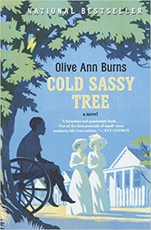
Cold Sassy Tree by: Olive Ann Burns
Big changes are on their way to the small town of Cold Sassy, Georgia, in 1906. Fourteen-year-old Will Tweedy is undergoing his own dramatic experiences—a near-death encounter with a train and his first romantic feelings—at the same time the world around him is starting to change.
After his grandmother dies, Will’s grandfather remarries a much younger woman, Miss Love. If that’s not enough scandal, the two find more ways to shock the town: dance-hall piano music, questions about racial and gender roles, and a new automobile. Follow Will through this dramatic year that changes him and the town he lives in forever.
Special Considerations: Possible sensitive issues in this classic novel include depictions of racial and socioeconomic prejudice and sexist attitudes representative of the time and setting. A character’s suicide and references to rape and incest are key plot elements but are handled with restraint.

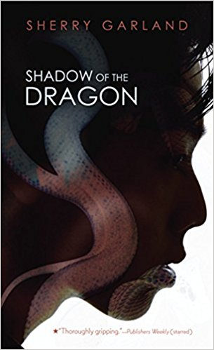
Shadow of the Dragon by: Sherry Garland What do you do when you’re torn between two worlds? In many ways, Danny Vo is a typical American teenager. He just wants to hang around with his friends and think about Tiffany Schulz, a pretty girl he worships from a distance. But Danny is also the oldest son in a traditional Vietnamese family. He has responsibilities and burdens that his American friends can’t understand. When his cousin Sang Le comes to Houston as a refugee from Vietnam, Danny must look after him. But when Sang Le falls in with a Vietnamese gang, Danny realizes he cannot protect his cousin from himself.
But Sang Le is not the only one in danger. Danny becomes a target of a different, even more dangerous gang: Tiffany’s brother and his racist skinhead friends. Danny must try to save Sang Le—and himself—from the dark cloud of violence that threatens them both.
Special Considerations: This novel contains depictions of violence, including a beating death and racism.

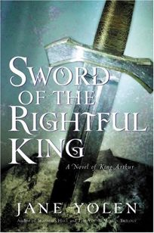
Sword of the Rightful King by: Jane Yolen
Young King Arthur is not happy. Appointed High King of Britain by the sorcerer Merlinnus, Arthur is uncomfortable on the throne. He is a just king and a strong and good-hearted man, but he is tired of passing judgment on his subjects all day. What’s worse, he knows that many of the people in Britain do not consider him the rightful heir to the throne. In fact, Queen Morgause is furious that Arthur is king. As the stepdaughter of the former high king, Morgause believes she is entitled to place one of her sons on the throne and rule through him. She is willing to use all means at her disposal—trickery, manipulation, black magic, assassins, and spies—to get rid of Arthur.
Only Merlinnus knows the truth about Arthur’s right to the throne. However, he can’t reveal this secret to the people of Britain, so he must find some other way to unite the people in loyalty to Arthur. One night Merlinnus has an idea—it has to do with a sword, a stone, and some magic. But when a mysterious boy named Gawen arrives at court, even Merlinnus can’t foresee what part this stranger will play in the plan.
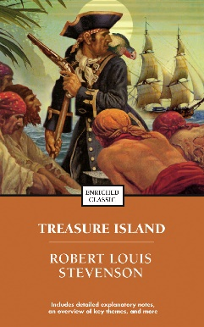
Treasure Island by: Robert Louis Stevenson
After a mysterious old sea dog named Billy Bones appears at the Admiral Benbow Inn, young Jim Hawkins’ life changes rapidly. First, Jim’s father dies. Then, after two old shipmates of Billy Bones pay Bones a visit, Bones dies too. Jim and his mother are left alone with the sailor’s trunk—a trunk that holds a map showing where the pirate Flint buried his treasure. Soon, Jim and two local men, Squire Trelawney and Dr. Livesey, are ready to set sail for Treasure Island on the Hispaniola. But the ship needs a crew. Trelawney hires an old sea cook, a one-legged fellow called Long John Silver. He’s surely an innocent, honest man—right?

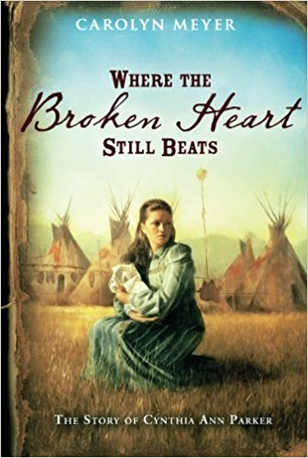
Where the Broken Heart Still Beats by: Carolyn Meyer
Cynthia Ann Parker was a nine-year-old girl living in a fort on the Texas frontier when the Comanche Indians attacked, killing several members of her family and taking her captive. She lived with the Comanche for almost 25 years, first as a slave, then as a wife and mother and a full-fledged member of the tribe. But the Parker family never forgot. Cynthia Ann—who called herself Naduah—was finally re-captured and brought back to live in the white community, against her will. This historical novel tells her story after her recapture, often flashing back to her memories of life with the Comanche. It describes the often-violent clashes between Native Americans and white settlers in Texas, Cynthia Ann’s new relationships with members of her biological family, and her longing to return to her Comanche family.
Special Considerations: Meyer’s novel is based on a true story and addresses attitudes and practices typical of people living in nineteenth-century Texas. Sensitive issues include ethnic and racial prejudice, as well as descriptions of violence, in the context of conflicts between American Indians and white settlers and of the Civil War.

Major Works Data Sheet

NAME: Period:
Title  Author  Date of Publication  Genre | Biographical information about the author
Historical information about the period of publication | Characteristics of the genre
Describe the author's style | An example that demonstrates the author's style
Memorable Quotes (Minimum of 3) | Significance of Quote
MWDS
Character Name and Role | Significance and Description of characters
Setting | Why is the setting important to the novel?
Symbols (and meanings) | Significance of Opening Scene/Closing Scene
Possible Themes ---Topics of Discussion | Discuss the most important theme:

Grading rubric
The essay responses are graded according to a 9 point scale. See commentary below:

9–8: These essays offer a well-focused and persuasive analysis of the topic. Using apt and specific textual support, these essays fully explore the topic and demonstrate what it contributes to the meaning of the work as a whole. Although not without flaws, these essays make a strong case for their interpretation and discuss the literary work with significant insight and understanding. Generally, essays scored a 9 reveal more sophisticated analysis and more effective control of language than do those scored an 8.

7–6: These essays offer a reasonable analysis of the topic. They explore the topic and demonstrate what it contributes to the meaning of the work as a whole. These essays show insight and understanding, but the analysis is less thorough, less perceptive, and/or less specific in supporting detail than that of those in the 9–8 range. Generally, essays scored a 7 present better-developed analysis and more consistent command of the elements of effective composition than do those scored a 6.

5: These essays respond to the assigned task with a plausible reading, but they tend to be superficial or underdeveloped in analysis. They often rely on plot summary that contains some analysis, implicit or explicit. Although the essays attempt to discuss the topic and how it contributes to the work as a whole, they may demonstrate a rather simplistic understanding of the work. Typically, these responses reveal unsophisticated thinking and/or immature writing. They demonstrate adequate control of language, but they may lack effective organization and may be marred by surface errors.

4–3: These lower-half essays offer a less than thorough understanding of the task or a less than adequate treatment of it. They reflect an incomplete or oversimplified understanding of the work. They may not address or develop a response to how that relationship contributes to the work as a whole, or they may rely on plot summary alone. Their assertions may be unsupported or even irrelevant. Often wordy, elliptical, or repetitious, these essays may lack control over the elements of college-level composition. Essays scored a 3 may contain significant misreading and demonstrate inept writing.

2–1: Although these essays make some attempt to respond to the prompt, they compound the weaknesses of those in the 4–3 range. Often, they are unacceptably brief or are incoherent in presenting their ideas. They may be poorly written on several counts and contain distracting errors in grammar and mechanics. The ideas are presented with little clarity, organization, or supporting evidence. Particularly inept, vacuous, and/or incoherent essays must be scored a 1.

0: These essays do no more than make a reference to the task. Mostly summary.

— These essays either are left blank or are completely off topic.

Grade Equivalents

Score | Average | Letter Grade
0 or --- | 0% | F
1 | 50% | F
2 | 60% | F
3 | 65% | F
4 | 75% | C
5 | 80% | B-
6 | 85% | B
7 | 90% | A-
8 | 95% | A
9 | 100% | A+

