Advanced Placement English Language & Composition
Summer Reading assignment
Columbus High school
liberal arts college preparatory magnet
2019-2020 school year

AP LANGUAGE & COMPOSITION SUMMER READING LIST
The purpose for summer reading in AP English Language and Composition is to prepare you for the level of reading, writing, and thinking that is the hallmark of this course. The following selections are included on the approved AP Central College Board list for suggested readings for this course. Your reading and writing assignments are as follows:
JUNE 2019
- The Glass Castle by Jeannette Walls
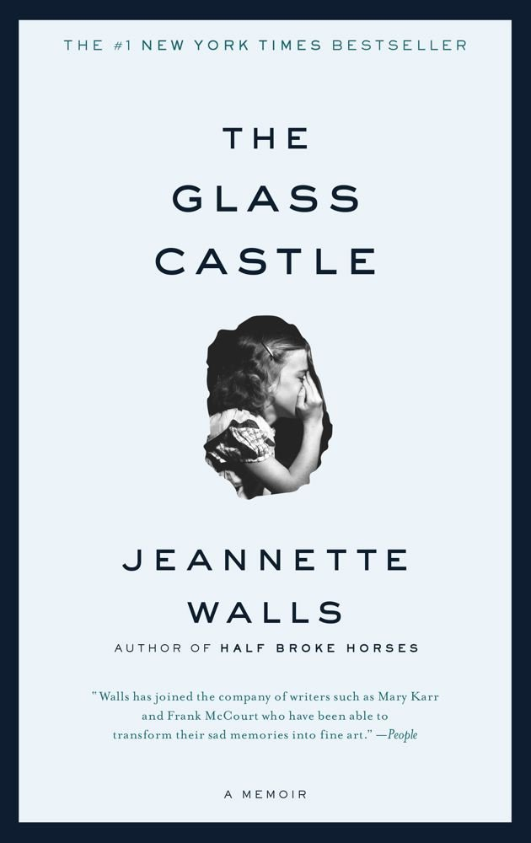
For this memoir, complete the reading and writing assignment by the end of June. Make sure that you annotate (write notes, questions, highlight, etc.) as you read. WRITE in your book, or if you read the novel online, write notes on paper. This will assist with your overall comprehension of the book. You will have a 50 point writing assignment to complete over the summer and a 100 point test on this non-fiction book within the first two weeks of school. Your writing assignment must be electronically submitted to the Google Classroom database BEFORE 11:59 pm on Friday, June 28, 2019. Late work (anything after 11:59 pm on Friday, June 28, 2019) will incur a 50% penalty for each day that it is late. Thus, you will only have one day to submit a late assignment. If you have any issues with Google Classroom when submitting, email Mrs. Williamson with your assignment attached before the due date. However, your assignment will not be graded until it is submitted to Google Classroom. During the first week of school, assignments will be uploaded to turnitin.com. Please be mindful of avoiding plagiarism. The majority of your writing should be your own, and the similarity on Turnitin.com should not exceed 20%. Points will be deducted for any percentage in excess of 20%.
Parents & Students: Please feel free to contact Shannon Williamson via email at Williamson.Shannon.r2@muscogee.k12.ga.us with any questions or concerns you may have.

JULY 2019
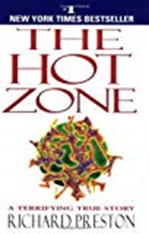
- The Hot Zone by Richard Preston
For this non-fiction book, which is a true account of the study of Marburg and Ebola viruses, complete the reading and writing assignment by the end of July. Make sure you annotate (write notes, questions, highlight, etc.) as you read. WRITE in your book, or if you read the novel online, write notes on paper. This will assist with your overall comprehension of the novel. You will have a 50 point writing assignment (dialectical journal) to complete over the summer and a 100 point test within the first two weeks of school. Your writing assignment must be electronically submitted to the Google Classroom database BEFORE 11:59 pm on Wednesday, July 31, 2019. Late work (anything after 11:59 pm on Wednesday, July 31, 2019) will incur a 50% penalty for each day it is late. Thus, you will only have one day to submit a late assignment If you have any issues with Google Classroom when submitting, email Ms. Mills with your assignment attached before the due date. However, your assignment will not be graded until it is submitted to Google Classroom. During the first week of school, assignments will be uploaded to turnitin.com. Please be mindful of avoiding plagiarism. The majority of your writing should be your own, and the similarity on Turnitin.com should not exceed 20%. Points will be deducted for any percentage in excess of 20%.
Parents & Students: Please feel free to contact Lisa Mills via email at Mills.Lisa.K@muscogee.k12.ga.us with any questions or concerns you may have.

AUGUST 2019
- 5 Steps to a 5 for AP English Language and Composition* by Barbara Murphy and Estelle Rankin.
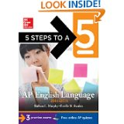
*You may get the most current edition OR one from the last few years will suffice. Purchasing this book is required, and it will assist you in exam preparation.
Rhetorical Terms - Definitions and Examples. This is individual work, and you must complete your own work! Any work submitted which looks alike or too closely similar will be investigated for possible plagiarism. Type complete definitions for the rhetorical terms (listed on last page of this document), and provide an example for each. You should also learn these terms as you will be applying them during annotations. If you have difficulty understanding a term, there are many resources online to assist you with understanding. Submit your typed definitions and examples to your AP English Language teacher on the FIRST day of class. If work is not submitted on the due date, it may be submitted on the following day for a deduction of 50%. No work will be accepted after the 2nd day. You will be tested over these terms within the first two weeks of school, so you should spend time studying and learning them in August!

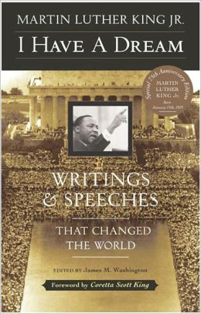
I Have a Dream: Writings and Speeches that Changed the World by Dr. Martin Luther King Jr. Edited by James M. Washington.
Purchasing this book is required if you do not have access to print long online documents. The texts we will be reading can be found online, but being able to annotate in the book will be helpful in your understanding and analysis. There will be no questions on the summer reading test about this text. However, we will read and analyze many of the documents in this book – some in the first few weeks of school.

AP LANGUAGE & COMPOSITION SUMMER WRITING ASSIGNMENT INSTRUCTIONS:
You will complete writing assignments for Jeannette Walls’ The Glass Castle and Richard Preston’s The Hot Zone. Both of your assignments (June-Glass Castle; July- The Hot Zone) must be typed and submitted electronically to Google Classroom. Please read below to see how to access the Google Classroom database, how to post to the database correctly, and how to complete the writing assignments. In addition to submitting your work electronically, make sure that you also save an electronic copy of all of your summer work (on a portable flash drive or other portable device). All written work (essay & journal) will be uploaded to the turnitin.com database during the first week of school.

ABOUT GOOGLE CLASSROOM
This database will serve as the electronic reservoir for all of your summer reading assignment work. Please keep in mind that all of your assignments should be YOUR original work and your work ALONE. Do NOT be tempted to share answers with another student or plagiarize from the internet because it will be easily detected. Should any student(s) be found guilty of plagiarizing or copying another student’s work, he or she will receive a zero on the summer reading assignment, will have his or her parents contacted, will receive permanent documentation on your school transcript, will be stripped of any academic honors for a full school year, and will appear before the CHS Honor Council for further disciplinary action. As our school motto reads, “Commitment, Honor, and Success,” we expect your work to mirror our desire for your personal success and academic excellence.
Creating a Google Account/Signing up for Google Classroom
• This summer we will be using Google Classroom for your assignments. You will need to create a Gmail account if you don’t already have one (remember it needs to be a school appropriate email that includes your first and last name). You will then login in to Google Classroom in order to complete your summer assignments. This can be done on any device, and there is an app available for both android phones and iPhones.
• Step one: Go to Gmail.com and sign up for an account (if you already have an account, login)
• Step two: At the top right next to your login (letter within the circle), click the google apps button. It is a 3x3 of squares.
• Step three: Click more on the apps page. Then click classroom.
• Step four: On the right side of the page, click the +, and join a class. Enter r6ayg5 as the class code if your last name starts with letters A-L, and enter efyp65s as the class code if your last name starts with letters M-Z.
• Now you are in the class and on google classroom. Here you should be able to navigate the class and assignments from the homepage.
• To turn in your assignments, click on the name of the assignment and upload your essay as a Word document.

GRADING
During the first week of school, you will submit your assignments to turnitin.com. Your AP Lang teacher will provide you more instructions regarding how to log in and submit your work. Please be aware should you be found guilty of plagiarism (either copying or allowing someone to copy your work), you will receive a zero. Grade penalties will be calculated based on your overall % matching to other sources submitted to the turnitin.com database as well as other online documents. YOUR ESSAY SHOULD NOT EXCEED 20%! Commonality in excess of 20% will receive grade deductions and potentially a zero on the assignment. Please keep in mind that you will also lose points should you submit your work late. DO YOUR OWN WORK, AND SUBMIT IT ON TIME!

JUNE WRITING ASSIGNMENT
JEANNETTE WALLS’ THE GLASS CASTLE
DUE: BEFORE 11:59PM ON FRIDAY, JUNE 28, 2019 TO GOOGLE CLASSROOM
Submit this to Google Classroom in ONE Microsoft Word document before the assigned due date. For questions regarding this assignment, email Shannon Williamson.

I. Assertion Short Write Response: 50 points
Select ONE of the prompts from below, and argue whether you agree (defend), disagree (challenge), or qualify (agree in some aspects but disagree in others). You must use concrete examples from the novel as evidence to prove your opinion. Your answer must include at least 2-3 examples from The Glass Castle (quotes or summary of particular details from the story in MLA format). You may also use your personal experiences, and/or what you have learned previously (through reading or historical examples) as evidence. A high scoring response will contain multiple examples to prove your opinion. Your response should be at least 500-700 words and include a word count.

Your response should contain an inviting introduction with a clear thesis, supporting body paragraphs, and a satisfying conclusion. Keep in mind to include examples from the text, from your personal experience, and/or examples from other books you have read or examples from history. As you compose your response, please consider the following:
- Make sure you cite the page numbers (in MLA format) when you cite from the book.
- Provide specific evidence from personal observation, experience, and/or reading to support your position. For this assignment, you must have evidence from The Glass Castle.
- Note its complexity (nuances) and forge connections between your position and that of the writer. Resist the immature temptation of oversimplification!
- Provide a conclusion that does not merely summarize, but rather addresses the “so what?” issue: How should educated, informed citizens continue to think about the issue at hand? How will it continue to influence readers’ lives?
- Submit your responses to the Google Classroom database in the requested format (one page, 12 point Times New Roman font, and single spaced in a Microsoft Word document). Quote and author should be typed at the top of the page. The words in the quote do NOT comprise part of the 500+ word response.

II. PROMPTS: Select only ONE quote from the choices below:

“Parents can only give good advice or put them on the right paths, but the final forming of a person's character lies in their own hands.” -Anne Frank

“Children have never been very good at listening to their elders, but they have never failed to imitate them.”
-James Baldwin

“We could never learn to be brave and patient if there were only joy in the world.” -Helen Keller

“People are just as happy as they make up their minds to be.” -Abraham Lincoln

“Money has never made man happy, nor will it, there is nothing in its nature to produce happiness. The more of it one has the more one wants.” -Ben Franklin

“Success is to be measured not so much by the position that one has reached in life as by the obstacles which he has overcome.” -Booker T. Washington

III. GRADING: Your typed response should be at least 500 words and single spaced. Each response will be evaluated according to the following criteria:
1. Did you fully explain the author’s position (the quote)?
2. Did you make clear in the introduction your position on the quote (thesis statement -defend, challenge, or qualify)? Did you make sure to note the complexities of the argument without oversimplifying?
3. Did your body paragraphs list specific reasoning for why you agree, disagree, or qualify, giving textual evidence in MLA format to support your reasoning?
4. Did your conclusion do more than merely summarize, but instead offer final thoughts on a complex issue?

IV. SAMPLE STUDENT RESPONSE:

“Parents can only give good advice or put them on the right paths, but the final forming of a person's character lies in their own hands.”
- Anne Frank

Many spend a lifetime defining themselves as individuals; a lifelong journey that begins in adolescence and transcends into adulthood. This journey, however, is not without the aid of others. Parents and friends have enough potential to influence someone’s life as is allowed to them. It is the individual who then decides what will affect them in life. Like Frank, teenagers are most aware of this transition; following past traditions to be responsible for their life.
Despite a reputation for defiance, the years spent arguing as a teenager are seemingly necessary to develop one’s future. As social creatures, many people’s attention is set on how they may be viewed by others rather than by themselves. Teens are just beginning to create an identity for themselves, one reflecting what they believe, rather than the beliefs of the family.
In Jeanette Walls’ memoir, The Glass Castle, she begins struggling with her parents’ way of life once she acknowledges it is not one she wants for herself. A defining moment in this transition is when Wall compares her mother’s writing aspirations to professional journalists and concludes, “I decided I wanted to be one of the people who knew what was going on” (204). Not only does she spotlight qualities she wants to aspire to, but also notes negative traits of her mother that she does not want herself. Echoing Frank’s observation that after years of absorbing qualities and beliefs from parents, it is then the duty of the teen to evaluate what remains important to them and apply it to their life.
Dating back to Ancient Greece, varying religious and cultural ceremonies have been known to celebrate the first steps into the adult world. In places like Sparta, young males were usually given a mentor that would guide them and give them the skills needed to be successful as an adult. In the Baha’i faith, when a child reaches the appropriate age it is the obligation of the child to decide whether or not they wish to remain in the faith. This is similar to some Christian baptismal rituals in which they are baptized once as a child and then again at a later age, if they choose to reaffirm their beliefs. Wall’s mother also placed all religious responsibilities on her children saying, “It was up to every human being to find his or her own way into heaven” (207). In the face of being raised with certain beliefs and practices, in many religions and cultures, it is the choice of the individual for what they wish to dedicate their life.
By the latter end of the transition into adulthood, young people are expected to be able to make the right decisions without the constant support from parental figures as was usual before. Despite having a seemingly constant faith in her parent’s schemes, Walls takes a stand, like so many others, and distances herself from the childhood fantasies fed to her. She rejects what she was taught and makes the decision that her own life would not be centered on the Glass Castle, she tells her father, “Go ahead and build the Glass Castle, but don’t do it for me” (238). However, just because teens are now responsible for their own lives, it does not mean they will make the right choices, but from that transitional point on, the young adult is accountable for the decisions that shapes his or her own character; whether it is for good or bad.
Life is difficult. It is no easier for one person than it is the other. Although the tribulations vary, they remain constant in everyone’s lives. At some point, however, each person has to take responsibility for his or her own life; defining their character according to their personal views. Their values will fail them, and they will make mistakes, but they will learn. To go through life dependent and without the possibility of making mistakes, is to go through life without living.
(654 words)

JULY WRITING ASSIGNMENT
RICHARD PRESTON’S – THE HOT ZONE
DUE: BEFORE 11:59PM ON TUESDAY, JULY 31, 2019 TO GOOGLE CLASSROOM
Submit this to Google Classroom in ONE Microsoft Word document before the assigned due date. For questions regarding this assignment, email Lisa Mills.

A New York Times Bestseller, The Hot Zone is a true account of the Marburg and Ebola viruses. The book details scientific truths and details regarding a potential outbreak. Though the novel contains scientific graphic details, the author employs a style that makes this novel very readable.
Your task is to read the novel, and complete the following critical reading and writing activities:

1. As you read, you will write a dialectical journal in which you pick 10 significant passages from the book. These passages should demonstrate your engagement with the novel; thus, they should be chosen from different parts of the book. You may give your personal reaction to the selected passage, discuss ideas or actions of the author or character(s), make connections, write what the passage makes you think or feel, analyze the passage and its relationship to the story as a whole, or analyze the text for the use of rhetorical devices (imagery, structure, style, tone, rhetorical appeals such as ethos, pathos, logos, diction, etc.) The purpose of the dialectical journal is to help you develop a better understanding of the text as you read. Each response should be at least 3-6 sentences in length (required 50 words or more).
2. Prepare your dialectical journal (via a Word document) that includes the quote from the novel written in MLA format (with page number) as well as your written response in the third column.
4. Prepare your entries in a three-column format as the following model illustrates. You may NOT use the following example as one of your ten required entries. Remember, your dialectical journal entries will be due no later than 11:59pm on Wednesday, July 31st, 2019 to Google Classroom. Please include your name & assignment title – The Hot Zone – Dialectical Journal

Dialectical Journal format is as follows:
 | Quote/Passage from the novel: | Analysis & Significance:
1 | “Everything had gone wrong inside this man, absolutely everything, any one of which could have been fatal: the clotting, the massive hemorrhages, the liver turned into pudding, the intestines full of blood. Lacking words, categories, or language to describe what had happened, they called it finally, a case of ‘fulminating liver failure’ ” (Preston 18). | In this passage the author utilizes scientific details and imagery to describe what Monet suffered after encountering what is perhaps the origin of the virus. This passage reveals the scientific studies in the initial stages prior to isolating a virus or cause of transmission. Perhaps this is the author’s way of shocking the reader into realizing the harsh realities of such a devastating virus while also recognizing the importance of ending its transmission.  (71 words)
 | - MLA format required! | - Word count required!

GRADING FOR JULY WRITING ASSIGNMENT (50 points—5 points per entry)
In order to receive full credit, you must meet the following criteria for each entry:
1. Did you follow the correct MLA format for the quote or passage and the three column format as shown
above?
2. Did you give appropriate explanation of your reasoning for the significance of the quote with at least
3-6 sentences and at least 50 words (with word count) per entry?

Please refer to the next page for your August assignment on rhetorical terms!

AP English Language & Composition - Understanding Rhetorical Terms – Mills/Williamson

Purpose: Knowing the following rhetorical terms will allow you to better discuss an author’s work at a more sophisticated level as you discuss how an author achieves his or her purpose. Throughout this course you will learn approximately 100 rhetorical terms, so learning these this summer will certainly be advantageous for you in the coming year.

Directions: Type complete definitions for the following rhetorical terms, and provide an example for each. You should also learn these terms. If you have difficulty understanding a term, there are many resources online to assist you with understanding. Submit your typed definitions and examples to your AP English Language teacher on the first day of class. If work is not submitted on the due date, it may be submitted on the following day for a deduction of 50%. No work will be accepted after the 2nd day. You will be tested over these terms within the first two weeks of school.

Example: Onomatopoeia – A figure of speech in which natural sounds are imitated in the sounds of words
Example: buss, hiss, crack, whinny

Terms:

1. Allegory
2. Alliteration
3. Allusion
4. Ambiguity
5. Analogy
6. Anaphora
7. Anecdote
8. Antecedent
9. Antithesis
10. Aphorism
11. Apostrophe (the figure of speech – not the punctuation mark)
12. Asyndeton
13. Atmosphere
14. Chiasmus
15. Clause - (Dependent & Independent)
16. Colloquialism
17. Coherence
18. Conceit (similar to metaphor)
19. Connotation
20. Denotation
21. Diacope
22. Diction
23. Didactic
24. Enumeratio
25. Expletive
26. Euphemism
27. Exposition
28. Extended metaphor
29. Genre
30. Homily
31. Hyperbole
32. Hypophora
33. Imagery

